SANDBOX DOCUMENTATION
(ABDM_Milestone 3)
Version 2.6
Updated on 13.02.2026
Contents
1 Base URL and X-CM-ID 3
1.1 IP Address whitelisting for call-back. 3
2 Terminology Definition: 3
3 Gateway flow 3
3.1 Overview 3
3.2 API Information Request & Response 4
3.2.1 Auth token API 4
3.2.2 OpenID Configuration API 6
3.2.3 OAuth Certificate API 7
3.2.4 Update bridge URL API 11
3.2.5 Registration of Facility & Software Linkage 12
3.2.6 Find bridge by service id 15
3.2.7 Find services by bridge id 17
4 Consent flow 20
4.1 Overview 20
4.2 Sequence Diagram 22
4.3 API Information Request & Response 23
4.3.1 HIE-CM - Consent request init 23
4.3.2 HIE-CM- Consent request init - call back 57
4.3.3 HIE-CM- Callback API to HIU when a consent request is APPROVED/REVOKED/DENIED 59
4.3.4 HIE-CM – API for HIU to respond back to consent HIU callback 61
4.3.5 HIE-CM- Consent request status 64
4.3.6 HIE-CM - Consent request on-status (Callback) 68
4.3.7 HIE-CM - Consent request fetch 70
4.3.8 HIE-CM - Consent request on-fetch (callback) 74
5 Data flow 81
5.1 Overview 81
5.2 Sequence Diagram 82
5.3 API Information Request & Response 82
5.3.1 Data flow – Data request invoked by HIU 82
5.3.2 Data flow – call back to HIU 86
5.3.3 Notify 88
6 Subscription flow 91
6.1 Overview 91
6.2 Sequence Diagram 92
6.3 API Information Request & Response 93
6.3.1 Users get subscription requests 93
6.3.2 User subscription request initiate 96
6.3.3 User Subscription request initiate – Call Back 98
6.3.4 Approve Subscription Request 100
6.3.5 Approve Subscription – Call back 105
6.3.6 Subscription Request Hiu – on notify 108
6.3.7 Deny Subscription Request 109
6.3.8 Deny Subscription – Call Back 111
6.3.9 Edit Subscription 113
6.3.10 Edit Subscription – call back 118
6.3.11 Subscription HIU –notify 120
6.3.12 Subscription HIU –On-notify 124
7 API listing 125

Base URL and X-CM-ID
Environment | Base URL | X-CM-ID
Sandbox | https://dev.abdm.gov.in | sbx
Production | https://apis.abdm.gov.in | abdm

IP Address whitelisting for call-back.
Environment | NAT IPs:
Sandbox | 13.203.243.253  13.203.245.166  65.0.113.207
Production | 13.203.243.253  13.203.245.166  65.0.113.207

Terminology Definition:
Bridge ID: Is client ID which provided by NHA to HIP (Its alphanumerical eg: SBX_00XXXX)
Service ID: Is Facility ID which is generated from NHPR application (Its alphanumeric eg:
IN02100000XX)

Gateway flow

Overview
This is the key ABDM building block that manages ABHA addresses, maintains links to health data for each ABHA address and manages consents provided by the user for sharing of their health data. It also supports exchange of interoperable health data between HIPs and HIUs.
The HIE-CM enables exchange of personal health data with consent as per the Health Data Management Policy issued by NHA.

API Information Request & Response

Auth token API
This API will be invoked to generate auth token.
URL: /api/hiecm/gateway/v3/sessions
Request: POST

Header Parameters:
Property Name | Example Value | Required | Description
REQUEST-ID | 18235d89-cb13-479d-ad71-  7a57d5f669a8 | Yes | Unique UUID for tracking the endtoend request transaction
TIMESTAMP | 2022-10-06T10:10:00.587Z | Yes | The actual time when the request was initiated, ISO Date time format represents the date and time
X-CM-ID | Sbx | Yes | Suffix of the consent manager to which the request was intended.
Body Parameters:
Property Name | Example Value |  | Required | Description
clientId | SBX_XXXXXX | Yes |  | Client id for authentication
clientSecret | “XXXXXXXXXXXXX” | Yes |  | Client secret for authentication
grantType | client_credentials | Yes |  | Grant type for authentication
Request Body:
Request Body
{
"clientId": "SBX_XXXXX",
"clientSecret": "XXXX-XXX-XXXX-XXXX-XXXXXXX",
"grantType": "client_credentials"
}

Response:
Response
Code : 202 Accepted
{
"accessToken":
"eyJhbGciOiJSUzI1NiIsInR5cCIgOiAiSldUIiwia2lkIiA6ICJBbFJiNVdDbThUbTlFSl9JZk85ejA2ajlvQ3Y1MXBLS 0ZrbkdiX1RCdkswIn0.eyJleHAiOjE3MjMyMjU3MTEsImlhdCI6MTcyMzIyNDUxMSwianRpIjoiMzE3MjVkN2Qt
NmM1Mi00OWE0LTk0M2MtZmY2ZjhkNjNhYmRlIiwiaXNzIjoiaHR0cHM6Ly9kZXYubmRobS5nb3YuaW4vYX
V0aC9yZWFsbXMvY2VudHJhbC1yZWdpc3RyeSIsImF1ZCI6ImFjY291bnQiLCJzdWIiOiJjN2NhMjk3Yi0yZTVh
LTRkN2UtOGY5YS0xYWU2NDAxYWQ0Y2YiLCJ0eXAiOiJCZWFyZXIiLCJhenAiOiJTQlhfMDAwMTM1Iiwic2Vzc 2lvbl9zdGF0ZSI6IjhiYjQ4ZGM5LTJmMDUtNDA0OC05MGUxLWRjYjgxNWRmOGU5MyIsImFjciI6IjEiLCJhbGx vd2VkLW9yaWdpbnMiOlsiaHR0cDovL2xvY2FsaG9zdDo5MDA3Il0sInJlYWxtX2FjY2VzcyI6eyJyb2xlcyI6W
yJIaWRJbnRlZ3JhdGVkUHJvZ3JhbSIsIkhJVV9QQVlFUiIsImhmciIsImhpdSIsIm9mZmxpbmVfYWNjZXNzIi wiaGVhbHRoSWQiLCJwaHIiLCJPSURDIiwiaGVhbHRoX2xvY2tlciIsImhpcCIsImhwX2lkIl19LCJyZXNvdXJjZV 9hY2Nlc3MiOnsiU0JYXzAwMDEzNSI6eyJyb2xlcyI6WyJ1bWFfcHJvdGVjdGlvbiJdfSwiYWNjb3VudCI6eyJy b2xlcyI6WyJtYW5hZ2UtYWNjb3VudCIsIm1hbmFnZS1hY2NvdW50LWxpbmtzIiwidmlldy1wcm9maWxlIl19f Swic2NvcGUiOiJvcGVuaWQgZW1haWwgcHJvZmlsZSIsImNsaWVudEhvc3QiOiIxMDAuNjUuMTYwLjIxNCI sImNsaWVudElkIjoiU0JYXzAwMDEzNSIsImVtYWlsX3ZlcmlmaWVkIjpmYWxzZSwicHJlZmVycmVkX3VzZXJ uYW1lIjoic2VydmljZS1hY2NvdW50LXNieF8wMDAxMzUiLCJjbGllbnRBZGRyZXNzIjoiMTAwLjY1LjE2MC4yMTQi
fQ.L56AYZYfzFrO_gNedAbSwR9foEO661z2cMGEeOKsz2ZXsIpTb9oLd9fmRiixIS7ToGoW2VzzXC14qrXnwZIqknBZchTRJrmyGk
6iRJN QYR4k12hrn4tbdW- h5e9m4NWFAvPtGbBUyKA8gotrne9fn7T0MOC7N_J8TS3JLr2gothJSgc9P3VDKm8c6zpAObQPmwEpH qJH6j2Q07nGsoaBygxovoIeFn6G6zwIa-_mKw_a86L_CYxr8Gxw5-
5PXkh2XwYp_xLIiJ3t7vLM97UFThwSn_TmRF6W1LH145m_6NxY4hQclHi1elK3OP4LvR1SLDwtAQZSCm4Jpihd0uMw",
"expiresIn": 1200, "refreshExpiresIn": 1800,
"refreshToken":
"eyJhbGciOiJIUzI1NiIsInR5cCIgOiAiSldUIiwia2lkIiA6ICIyMWU5NzA4OS00ZTcxLTQyNGEtOTAzYS1jOTAyMW M1NmFlNWYifQ.eyJleHAiOjE3MjMyMjYzMTEsImlhdCI6MTcyMzIyNDUxMSwianRpIjoiZGY5ODdmYzQtYzdk Ni00OGNmLTliM2EtNzRmNWVkMTljMmNmIiwiaXNzIjoiaHR0cHM6Ly9kZXYubmRobS5nb3YuaW4vYXV0a C9yZWFsbXMvY2VudHJhbC1yZWdpc3RyeSIsImF1ZCI6Imh0dHBzOi8vZGV2Lm5kaG0uZ292LmluL2F1dGg vcmVhbG1zL2NlbnRyYWwtcmVnaXN0cnkiLCJzdWIiOiJjN2NhMjk3Yi0yZTVhLTRkN2UtOGY5YS0xYWU2ND AxYWQ0Y2YiLCJ0eXAiOiJSZWZyZXNoIiwiYXpwIjoiU0JYXzAwMDEzNSIsInNlc3Npb25fc3RhdGUiOiI4YmI0O GRjOS0yZjA1LTQwNDgtOTBlMS1kY2I4MTVkZjhlOTMiLCJzY29wZSI6Im9wZW5pZCBlbWFpbCBwcm9maWx lIn0._cOnTXMf2bObS1nySL-AjvM5PQxgCHJRm2oO66nrx1M",
"tokenType": "bearer"
}

OpenID Configuration API
Openid-configuration API, defined within OpenID Connect which provides configuration information about the Identity Provider (IDP).
URL: /api/hiecm/gateway/v3/.well-known/openid-configuration
Request: GET
Header Parameters:
Property Name | Example Value | Required | Description
REQUEST-ID | 18235d89-cb13-479d-ad71-  7a57d5f669a8 | Yes | Unique UUID for tracking the endto-end request transaction
TIMESTAMP | 2022-10-06T10:10:00.587Z | Yes | The actual time when the request was initiated, ISO Date time format represents the date and time
X-CM-ID | Sbx | Yes | Suffix of the consent manager to which the request was intended.
Response:
Response
Code : 202 OK
{
"jwks_uri": "https://dev.abdm.gov.in/api/hiecm/gateway/v3/certs"
}

OAuth Certificate API
This API provide an OAuth certificate that can be used to validate which received gateway session token in Header on the call back.
URL: /api/hiecm/gateway/v3/certs
Request: GET

Header Parameters:
Property Name | Example Value | Required | Description
REQUEST-ID | 18235d89-cb13-479d-ad71-  7a57d5f669a8 | Yes | Unique UUID for tracking the endtoend request transaction
TIMESTAMP | 2022-10-06T10:10:00.587Z | Yes | The actual time when the request was initiated, ISO Date time format represents the date and time
X-CM-ID | Sbx | Yes | Suffix of the consent manager to which the request was intended.
Response:
Response
Code : 202 OK
{
"keys": [
{
"e": "AQAB",
"kid": "AlRb5WCm8Tm9EJ_IfO9z06j9oCv51pKKFknGb_TBvK0",
"kty": "RSA",
"n": "mgmW7W5ZGF_G5cJevwYi8HiPcI-6qS_psnZxa4v3bkwAkyOoOd8-6ketrOI-
ZA2PbRbGnxFfZHiI94rdFXJ4Q9ampscsz9NocTIPMPmWydJ8A50pZaYWyikYDSJiDltq7i3WspPKSOuQHrC
5h9dMcCVveX5oeg0tO68Z79gwDlpcxiqDbFaphsqDvx-
5XkfwiqvOBaybK6_BCBPuTqWMUEuUklLYXu2X7ESHdVNFMFAjxCcCXUtP7LFdvT3nnFekRmG82QbSQSVe
4N5tPH8q0MCxSWWn2c15bDnzOF-dvfRCVPRabCzw0M-utHR9diTrWtq6Koi5buxgwM1rbk0p8Q",
"use": "sig",
"x5c": [

"MIICrzCCAZcCBgFy/3WZBjANBgkqhkiG9w0BAQsFADAbMRkwFwYDVQQDDBBjZW50cmFsLXJlZ2lzdHJ5
MB4XDTIwMDYyOTA5NDEzNloXDTMwMDYyOTA5NDMxNlowGzEZMBcGA1UEAwwQY2VudHJhbC1yZWdpc
3RyeTCCASIwDQYJKoZIhvcNAQEBBQADggEPADCCAQoCggEBAJoJlu1uWRhfxuXCXr8GIvB4j3CPuqkv6b J2cWuL925MAJMjqDnfPupHraziPmQNj20Wxp8RX2R4iPeK3RVyeEPWpqbHLM/TaHEyDzD5lsnSfAOdKWW mFsopGA0iYg5bau4t1rKTykjrkB6wuYfXTHAlb3l+aHoNLTuvGe/YMA5aXMYqg2xWqYbKg78fuV5H8Iqrzg WsmyuvwQgT7k6ljFBLlJJS2F7tl+xEh3VTRTBQI8QnAl1LT+yxXb0955xXpEZhvNkG0kElXuDebTx/KtDAsUllp9 nNeWw58zhfnb30QlT0Wmws8NDPrrR0fXYk61rauiqIuW7sYMDNa25NKfECAwEAATANBgkqhkiG9w0BAQs

FAAOCAQEACkC3TijrXIgi4vn+l1uL1nfdK6vOIL5UZ6yCjSOq7zYW6b3Qe8j7NrPb9RJC+pbIERyNbB+t9hsa5 g1L7lkjCNlUuxfJprsJ9LJKlM5g7dYEA6XPCJ7C6AVlarj72vlWXQvwjnQMO2/CM9/Jp5Hnv2Qwjn7NME2OW M0iblc/TD+DEZK5L5mlWMyuBSQo2o/AcOmfG4MoE5Gm/CaOJ47rSrf+lq83e5+dyKh7uLVAa+5WK8Im
5nEs6BLSGyo2KlaV0mW9yCkoRLLbipjH8+rJwkUU6iu7QVjz0peGZzYldya5n35gMWH7Bu4HqFneKNRww D6w8rGNC+uWtgWejDZ3yQ=="
],
"x5t": "EaMhYGUIvMkp8tvSM3QoaqaF8xM",
"x5t2": "vGer6Pt8AhZn8RlbHhAFksOCcGf3u1UWU7Qq-Doy7ro",
"alg": "RS256"
},
{
"e": "AQAB",
"kid": "oc-l6O1yJ7wJKYEeyeUafsz3Aecq7YnCIqbzbIfkJk8",
"kty": "RSA", "n":
"jDOehgMzurNQT0WJCTWN6a34639uIKOLO1LnXZes_kTakWh6iRxmkExLLCD7MJjz9aijTHwIuKAtOCSbFO pwbqSfF6dMBS2c8cv0AU3pE8kSM
BuUriwr9BUYSUW8SM68QH_HCaz2mmN_Z8ynTQ4kWw_Idj- enVpkHYtq00DriG98l6RXF1Ao9Kd16ctoNbthuQYH0RSRIXnt0Qtm4GSAY7abPCNa64mir0auldU72DJHXwDo6g5OGz6EMm86ZAV_pvh_5YzFpfk IMxv0yMMKFZjkFGA0QKYMkMTC5ruLaE7cec-njA7dJQnQ",
"use": "sig",
"x5c": [

"MIICrzCCAZcCBgGHxvQVmDANBgkqhkiG9w0BAQsFADAbMRkwFwYDVQQDDBBjZW50cmFsLXJlZ2lzdHJ 5MB4XDTIzMDQyODA4MTk1N1oXDTMzMDQyODA4MjEzN1owGzEZMBcGA1UEAwwQY2VudHJhbC1yZWdpc
3RyeTCCASIwDQYJKoZIhvcNAQEBBQADggEPADCCAQoCggEBAIwznoYDM7qzUE9FiQk1jemt+Ot/biCjiztS
512XrP5E2pFoeokcZpBMSywg+zCY8/Woo0x8CLigLTgkmxTqcG6knxenTAUtnPHL9AFN6RPJEjKRiSg2fXYg PgblK4sK/QVGElFvPkjOvEB/xwms9ppjf2fMp00OJFsPyHY/np1aZB2LatNA64hvfJekVxdQKPSndenLaDW7Y bkGB9EUkSF57dELZuBkgGO2mzwjWuuJoq9PmrpXVPu9gyR18A6OoOThs+hDJvOmQFf6b4f+WMxaX5FA PEytixVQJgt1KfiDMb9MjDChWY5BRgNECmDJDEwua7i2hO3HnPp4wO3SUJ0CAwEAATANBgkqhkiG9w0B
AQsFAAOCAQEABYAcXOSr+WgOxKVmygID9WjB4rDuAVDyU3GmjBvckdWhYJuBX8Vs04hNVNgf904gqy
+D5wZIQU985stK3PdogFGN2jVw2kO9G3hG4/7uwYKqciKApT/pSPMeHRltHGp/Mwr6e5poVwgQyrn+Be
H373U1Q6eB1QUYnElP+16y7bbvQhfDAS2X9sqdfurB9YIL5xZMPddZaf7pPX8oWOVlB0XH1JEZfsX125qq0Xn
K8z/Rd8KI8zTfJw6D2Kzrk1WvQSlM5KnTQmcSk3kwDlW5Dg657dT49Y68mI4azq34q17JgBhTx3IbTuf94QT w7QC5wmFtO+hc6zPVODX8JWu7

Update bridge URL API
This API will be called to update the bridge base URL.
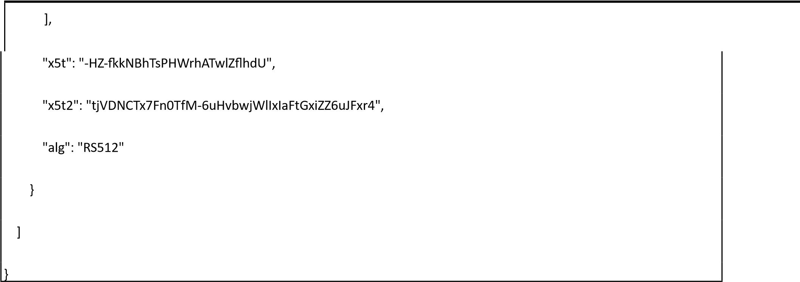
URL: /api/hiecm/gateway/v3/bridge/url Request: PATCH Header Parameters:
Property Name | Example Value |  | Required | Description
Authorization | eyJhbGciOiJSUzUxMiJ9. eyJzdWIiOiJ2YXNhbnRoY Wt1bWFyLmtlc2F2YW5Ac  2J4IiwiY2xpZW50SWQiOi  JzYngiLCJzeXN0ZW0iOiJ  BQkhBLUEiLCJyZXF1ZXN0Z  XJJZCI6IlBIUi1XRUIiLCJwa  HJNb2JpbGUiOm51bGws | Yes |  | JWT Access token which was issued by ABDM session API after successful validation of client id and secret.
REQUEST-ID | 18235d89-cb13-479dad71-  7a57d5f669a8 | Yes |  | Unique UUID for tracking the end-to-end request transaction
TIMESTAMP | 2022-10-  06T10:10:00.587Z | Yes |  | The actual time when the request was initiated, ISO Date time format represents the date and time
X-CM-ID | sbx | Yes |  | Suffix of the consent manager to which the request was intended.
Body Parameters:
Property Name | Example Value |  | Required | Description
url | https://webhook.site/b7  99c0b8-4e75-4545- 8eb2d8c2d5f0c9f6 | Yes |  | Bridge base URL
Request Body:
Request Body
{
"url": "https://webhook.site/b799c0b8-4e75-4545-8eb2-d8c2d5f0c9f6"
}

Response:
Response
Code : 202 Accepted

Registration of Facility & Software Linkage
Overview: The software being used by the provider must integrate with the digital building blocks of ABDM and comply with the guidelines outlined NHA. NHA maintains the national directory of all healthcare facilities. Any participating facility needs to sign up in the health facility registry at (nhpr.abdm.gov.in) This ensures that they are a valid facility which is authorized to issue health records in the ecosystem. HFR consists of information for each healthcare facility in the country – hospitals, clinics, diagnostic centers, pharmacies etc., across all systems of medicine and covering both public and private health facilities. HFR offers APIs that can be used by various stakeholders in the ecosystem. Healthcare information service provider application or healthcare repository provider application must be upgraded to become ABDM compliant.
Registration of facility:
Through website: https://hspsbx.abdm.gov.in/home (sandbox), https://nhpr.abdm.gov.in/home (production) Step-by-step user manual document access:
Goto: https://hspsbx.abdm.gov.in/home (sandbox) , https://nhpr.abdm.gov.in/home (production)
>>Resource center >> User Manual
>> Select “For Health Facility” >>Download “User Manual” >>Refer Content
“A” (Health Professional ID (HPID) creation), “B” (Facility Registration)

Registration of bridge services (HIP/HIU) on facility:
Option 1: Linking through website: https://hspsbx.abdm.gov.in/home (sandbox) , https://nhpr.abdm.gov.in/home (production) Step-by-step user manual document access:
Goto: https://hspsbx.abdm.gov.in/home (sandbox) , https://nhpr.abdm.gov.in/home ( production)
>>Resource center >> User Manual
>> Select “For Health Facility” >>Download “User Manual” >>Refer Content “C” (Software
Linkage)
Option 2: Through API
This API ( https://apihspsbx.abdm.gov.in/v4/int/v1/bridges/MutipleHRPAddUpdateServices )
will be used to link multiple bridges against a facility. It will accept the facility id , facility name and list
of HRP i.e. bridges.
Please note:
- You must pass in all the required parameters to create the API.
- The data needs to be passed in the required format as mentioned for each field.
API can refer swagger link :
https://apihspsbx.abdm.gov.in/v4/int/swagger-ui-ext/index.html#/Multiple%20HRP%20API/facilityAddAndUpdate >>>Go to Multi
HRP API >>>and Select “/v1/bridges/MutipleHRPAddUpdateServices
v1MutipleHRPAddUpdateServices”

Parameters:

Params | Required | Description | Data type | Format if any
facilityId | Yes | Will be validated if present in  HFR or not | String | Starting with IN and of 12 characters

facilityName | Yes | Name of the facility to be linked | String | Alphanumeric
bridgeId | Yes | Valid Bridge Id to be linked. | String | Alphanumeric and validity to be checked by HIECM
hipName | Yes | • To provide uniqueness against each bridges that is linked . HIP name is the name of the hospital which will reflect | String | • HIP name can be the Hospital name added with suffix of bridge name.  example
 |  | on ABHA/PHR app when the patent will search for the respective hospital. |  | Hospital nd name=XYZ  bridge nam  =BRIDGE TEST, the HIP name = XY  BRIDGE. • namHIP can not be more than 15 characters., No is special  character  allowed  (%$*#@(~&!), an it should be uniqu for every bridge fo  a facility
type | Yes | HIP / HIU etc | String | Validated by  HIECM
Active | Yes | True/false | boolean | Accept Boolean  value

Find bridge by service id
This API will fetch the bridge details for the given service id.
URL: /api/hiecm/gateway/v3/bridge-service/serviceId/{serviceId} Request: GET Header Parameters:
Property Name | Example Value |  | Required | Description
Authorization | eyJhbGciOiJSUzUxMiJ9. eyJzdWIiOiJ2YXNhbnRoY Wt1bWFyLmtlc2F2YW5Ac  2J4IiwiY2xpZW50SWQiOi  JzYngiLCJzeXN0ZW0iOiJ  BQkhBLUEiLCJyZXF1ZXN0Z  XJJZCI6IlBIUi1XRUIiLCJwa  HJNb2JpbGUiOm51bGws  ImV4cCI6MTY2NzI5ODEx NSwiaWF0IjoxNjY3MjkwO TE1LCJwaHJBZGRyZXNzIjo idmFzYW50aGFrdW1hci5 rZXNhdmFuQHNieCIsInR 4bklkIjoiYjEwMGM4ZDMt NTE1ZC00YWFiLTg1OWQtY zNlMTUwOTE3ZGY1In0 | Yes |  | JWT Access token which was issued by ABDM session API after successful validation of client id and secret.
REQUEST-ID | 18235d89-cb13-479dad71-  7a57d5f669a8 | Yes |  | Unique UUID for tracking the end-to-end request transaction
TIMESTAMP | 2022-10-  06T10:10:00.587Z | Yes |  | The actual time when the request was initiated, ISO Date time format represents the date and time
X-CM-ID | sbx | Yes |  | Suffix of the consent manager to which the request was intended.

Response:
Response
Code : 200 Ok
{
"id": 1561,
"bridgeId": "SBX_XXXX",
"serviceId": "TestClinicHIP",
"name": "TestClinicHIP",
"isHip": true,
"isHiu": true,
"isPhr": false,
"endpoints": {},
"active": true,
"registerTime": "2021-03-01 11:17:35.1735",
"dateCreated": "2021-03-01 11:17:35.1735",
"dateModified": "2024-04-22 11:04:46.446"
}

Find services by bridge id
This API will fetch all the service details for the bridge id from authorization token.
URL: /api/hiecm/gateway/v3/bridge-services
Request: GET

Header Parameters:
Property Name | Example Value |  | Required | Description
Authorization | eyJhbGciOiJSUzUxMiJ9. eyJzdWIiOiJ2YXNhbnRoY Wt1bWFyLmtlc2F2YW5Ac  2J4IiwiY2xpZW50SWQiOi  JzYngiLCJzeXN0ZW0iOiJ  BQkhBLUEiLCJyZXF1ZXN0Z  XJJZCI6IlBIUi1XRUIiLCJwa  HJNb2JpbGUiOm | Yes |  | JWT Access token which was issued by ABDM session API after successful validation of client id and secret.
REQUEST-ID | 18235d89-cb13-479dad71-  7a57d5f669a8 | Yes |  | Unique UUID for tracking the end-to-end request transaction
TIMESTAMP | 2022-10-  06T10:10:00.587Z | Yes |  | The actual time when the request was initiated, ISO Date time format represents the date and time
X-CM-ID | sbx | Yes |  | Suffix of the consent manager to which the request was intended.

Response:

Response
Code : 200 Ok
{
"bridge": {
"id": "SBX_XXXX",
"name": "Testing",
"url": "https://abdcb.doctor9.com",
"active": true,
"blocklisted": false
},
"services": [
{

"id": "@#$%^&*(",
"name": "hello",
"types": [
"HIP",
"HIU"
],
"endpoints": {
"hipEndpoints": [
{
"use": "registration",
"connectionType": "HTTPS",
"address": "https://events.hookdeck.com/e/src_3gsnEgI941mh/registration"
},
{
"use": "data-upload",
"connectionType": "HTTPS",
"address": "https://events.hookdeck.com/e/src_3gsnEgI941mh/data-upload"
}
],
"hiuEndpoints": [
{
"use": "registration",
"connectionType": "HTTPS",
"address": "https://events.hookdeck.com/e/src_3gsnEgI941mh/registration"
},
{
"use": "data-upload",
"connectionType": "HTTPS",
"address": "https://events.hookdeck.com/e/src_3gsnEgI941mh/data-upload"
}
],
"healthLockerEndpoints": [
{
"use": "registration",
"connectionType": "HTTPS",
"address": "https://events.hookdeck.com/e/src_3gsnEgI941mh/registration"
},
{
"use": "data-upload",
"connectionType": "HTTPS",
"address": "https://events.hookdeck.com/e/src_3gsnEgI941mh/data-upload"
}
]
},
"active": true
}
]
}

Consent flow

Overview
The service used to handle consent management before sharing the health data between the entities (HIP, HIU, PHIU)
There are a couple of essential attributes required for consent artefact like Purpose, HI Types, Access mode, Requester, Range, and Validity.
HIE-CM will validate HIU requests for authenticity, replay attack, timestamp, ABHA address, etc. The request will be saved into the database. The consent request id will be returned to the called HIU for future tracking purposes.
The valid requests will be broadcasted to the priority queue and sent to all the ABDM compliance Patient HIU (PHR application). The consent notification status will be saved into the database.
Upon successful acknowledgment, the consent artifact will be generated and saved into the database. HIECM will further share this consent artefact with HIP and HIU.

Sequence Diagram
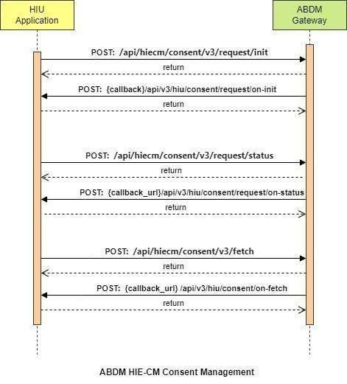

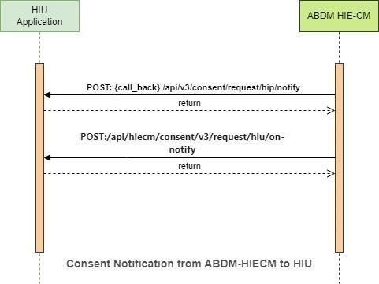

API Information Request & Response

HIE-CM - Consent request init
This is an API that will be invoked by HIU to initiate a consent request to get data about a patient.
While requesting and exchanging health information, there are meta codes that are relevant to you if you are a HIU.
• Purpose of Use - defines what is the purpose of use of the health information that a HIU is requesting for. The following are subset from http://terminology.hl7.org/ValueSet/v3-PurposeOfUse
Code
 | Display
CAREMGT | Care Management  Break the Glass  Public Health  Healthcare Payment
BTG
PUBHLTH
HPAYMT
DSRCH | Disease Specific Healthcare Research  Self-Requested
PATRQT

URL: /api/hiecm/consent/v3/request/init Request: POST Header Parameters:
Property  Name | Example Value | Required | Description
Authorization | Gateway Session Token | Yes | JWT Access token which was issued by ABDM session API after successful validation of client id and secret
REQUEST-ID | 18235d89-cb13-479d-ad71-  7a57d5f669a8 | Yes | Unique UUID for track the end to end request transaction
TIMESTAMP | 2022-10-06T10:10:00.587Z | Yes | Actual time when request was initiated, ISO Date time format represents date and time
X-CM-ID | sbx | Yes | Suffix of the consent manager to which the request was intended

Body Parameters:
Property Name | Example Value | Required | Description
Patient | abc@abdm | Yes | A unique and valid ABHA address suffix with @abdm for live and @sbx for Sandbox
Hip | ABDM_HIP | No | Health information provider ID
purpose – text | Care Management | Yes | Purpose text of consent request
Purpose-code | CAREMGT | Yes | Purpose code of consent request

Purpose-refUri | www.test.com | Yes | Purpose refUri of consent request
patientReference | batman@tmh | No | Patient reference  Id
careContextReference | Episode11 | No | Care context reference
Hiu | Sub_HIU | Yes | Health information user  Id
Requester-name | Smith | yes | Name of the requester
Requester-identifiertype | REGN01 | yes | Requester identifier type
Requester-identifiervalue | MH1001 | yes | Requester identifier value
Requester-identifiersystem | https://www.mciindia.org | yes | Requester identifier system
hiTypes | ["Prescription",  "DiagnosticReport",  "DischargeSummary  "ImmunizationRecord",  "HealthDocumentRecord",  "WellnessRecord",  "OPConsultation"] | yes | Type of document
PermissionaccessMode | VIEW | yes | Access mode of consent
PermissiondateRange | "from": "2023-05-09T08:58:09.738Z",  "to": "2023-05-10T08:58:09.738Z" | yes | Data range of permission required
PermissiondateEraseAt | 2023-05-25T08:58:09.738Z | yes | Date of erase data
Permissionfrequency-value | 0 | yes | Frequency value for consent
Permissionfrequencyrepeats | 0 | yes | Frequency repeats for consent
Permissionfrequency-unit | HOUR | yes | Frequency unit for consent
hiTypes | “PRESCRIPTION” | yes | hiTypes of the patient details. It is a list, there can be more than one hitype.

Request Body:
Request Body

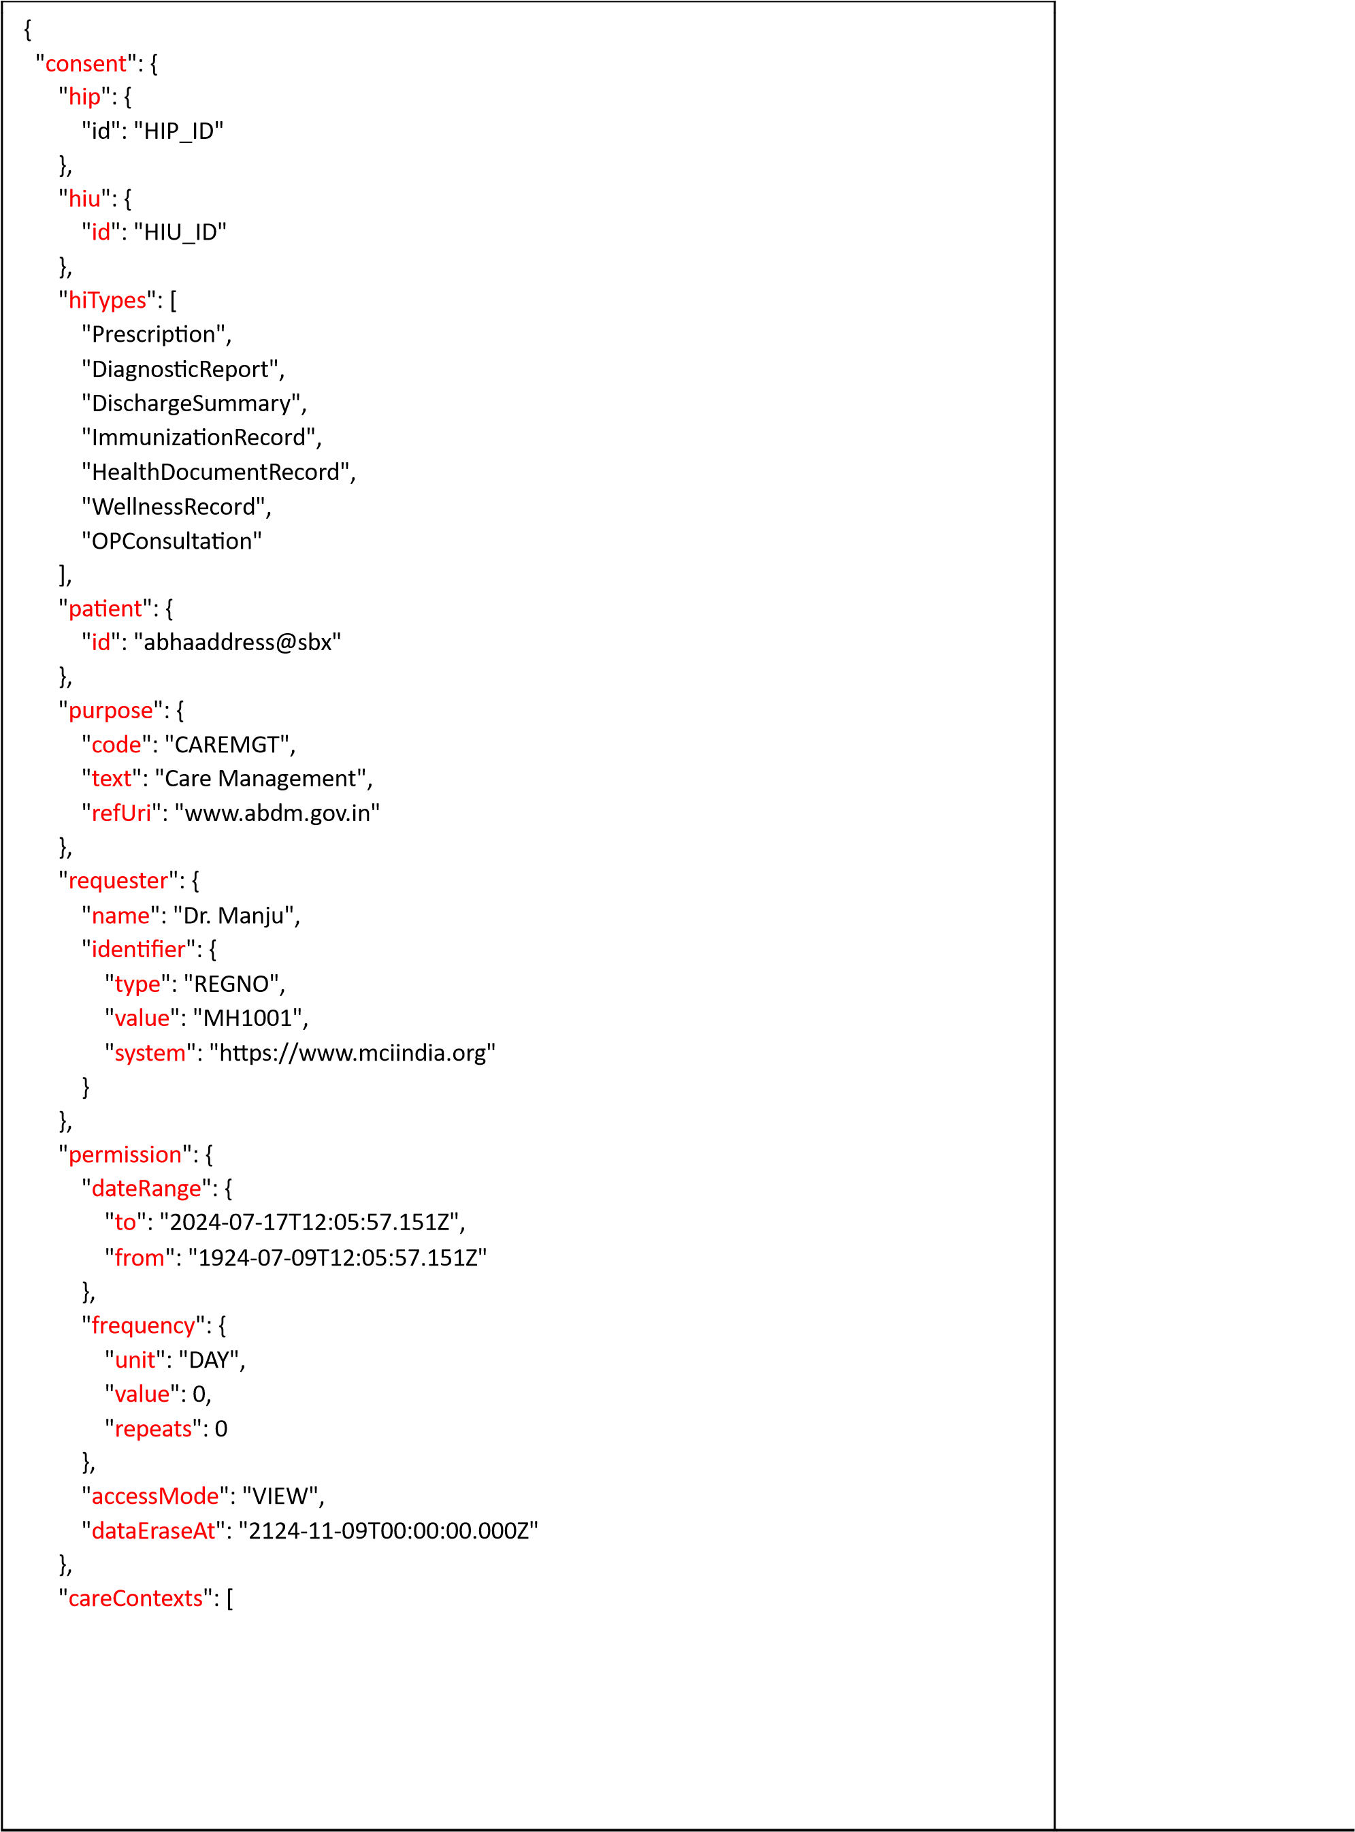

{

"
patientReference
": "xxxx@sbx",

"
careContextReference
": "COCa496bc2f
-
ca6c
-
5
af
4
-
b973
-
e915fd9815"
02

}

]

}

}

Response Body:
Response
Code : 202 Accepted

Error scenarios:
Scenarios | Request Body | Response
To verify when  Request ID is Blank, null or empty in header | [  {  "key": "REQUEST-ID", "value": "",  "type": "text"  }  ] | Access Denied  Code : 403 Forbidden
To verify when invalid RequestID is pass in header | [  {  "key": "REQUEST-ID",  "value": "{{$guid}}zxzzxs",  "type": "text"  }] | {  "code": "ABDM-1030: ",  "message": "Invalid request ID"  }  Code: 400Bad Request
When X-CM-  ID is Invalid, Blank, null or empty in header. | [  {  "key": "X-CM-ID",  "value": "sbxdvdfvdf",  "type": "text"  } | Access Denied  Code : 403 Forbidden

]

Verify  message when purpose text is empty or null | {  "consent": {  "purpose": {  "text": "",  "code": " CAREMGT",  "refUri": "string"  },  "patient": {  "id": "xxxxxxxxx@abdm"  },  "hip": {  "id": "HIP_ID"  },  "careContexts": [  {  "patientReference": "xxxxx@tmh",  "careContextReference": "Episode11"  }  ],  "hiu": {  "id": "HIU_ID"  },  "requester": {  "name": "Dr. xxxx",  "identifier": {  "type": "REGNO1",  "value": "MH10XX", | {  "code": "ABDM-9999",  "message": "Consent purpose text cannot be null"  }

"system": "https://www.xxxxxx.org"
}
},
"hiTypes": [
"OPCONSULTATION",
"WELLNESSRECORD"
],
"permission": {
"accessMode": "VIEW",
"dateRange": {
"from": "2023-05-09T08:58:09.738Z",
"to": "2023-05-10T08:58:09.738Z"
},
"dataEraseAt": "2023-05- 25T08:58:09.738Z",
"frequency": {
"unit": "HOUR",
"value": 0,
"repeats": 0
}
}
}
}
Verify  message when purpose text is not any of the following:  Care  Management,  Break the  Glass, Public  Health,  Healthcare  Payment, | {  "consent": {  "purpose": {  "text": "Care Management123",  "code": "CAREMGT",  "refUri": "string"  },  "patient": {  "id": "xxxxxxxxxxxxx@abdm" | {  "code": "ABDM-9999: ",  "message": "Invalid purpose text, it must  be in Care Management, Break the Glass, Public Health,  Healthcare Payment, Disease  Specific Healthcare Research, Self Requested"  }

Disease  Specific  Healthcare  Research, Self  Requested | },  "hip": {  "id": "SBX_HIP1"  },  "careContexts": [  {  "patientReference": "xxxxx@tmh",  "careContextReference": "Episode11"  }  ],  "hiu": {  "id": "HIU_ID"  },  "requester": {  "name": "Dr. xxxxx",  "identifier": {  "type": "REGNO1",  "value": "MH1001",  "system": "https://www.xxxxxx.org"  }  },  "hiTypes": [  "OPCONSULTATION",  "WELLNESSRECORD"  ],  "permission": {  "accessMode": "VIEW",  "dateRange": {  "from": "2023-05-09T08:58:09.738Z",  "to": "2023-05-10T08:58:09.738Z"  },

"dataEraseAt": "2023-05- 25T08:58:09.738Z",
"frequency": {
"unit": "HOUR",
"value": 0,
"repeats": 0
}
}
}
}

Verify  message when purpose code is empty or null | {  "consent": {  "purpose": {  "text": "Care Management",  "code": " ",  "refUri": "string"  },  "patient": {  "id": "xxxxxx@abdm"  },  "hip": {  "id": "HIP_ID"  },  "careContexts": [  {  "patientReference": "xxxxx@tmh",  "careContextReference": "Episode11"  }  ],  "hiu": {  "id": "HIU_ID"  }, | {  "code": "ABDM-9999",  "message": "Consent purpose code  cannot be null"  }

"requester": {
"name": "Dr. xxxxx",
"identifier": {
"type": "REGNO1",
"value": "MH1001",
"system": "https://www.mciindia.org"
}
},
"hiTypes": [
"OPCONSULTATION",
"WELLNESSRECORD"
],
"permission": {
"accessMode": "VIEW",
"dateRange": {
"from": "2023-05-09T08:58:09.738Z", "to": "2023-05-10T08:58:09.738Z"
},
"dataEraseAt": "2023-05- 25T08:58:09.738Z",
"frequency": {
"unit": "HOUR",
"value": 0,
"repeats": 0
}
}
}
}

Verify  message when purpose text is not any of the following:  CAREMGT,  BTG, PUBHLTH,  HPAYMT,  DSRCH,  PATRQT | {  "consent": {  "purpose": {  "text": "Care Management",  "code": "CARE",  "refUri": "www.ref.com"  },  "patient": {  "id": "xxxxxxx@abdm"  },  "hip": {  "id": "HIP_ID "  },  "careContexts": [  {  "patientReference": "xxxxxx@tmh",  "careContextReference": "Episode11"  }  ],  "hiu": {  "id": "HIU_ID "  },  "requester": {  "name": "Dr. Manjula",  "identifier": {  "type": "REGNO1",  "value": "MH1001",  "system": "https://www.mciindia.org"  }  },  "hiTypes": [  "OPCONSULTATION", | {  "code": "ABDM-9999",  "message": "Invalid purpose code, it must be in CAREMGT, BTG, PUBHLTH, HPAYMT, DSRCH, PATRQT"  }

"WELLNESSRECORD"
],
"permission": {
"accessMode": "VIEW",
"dateRange": {
"from": "2023-05-09T08:58:09.738Z",
"to": "2023-05-10T08:58:09.738Z"
},
"dataEraseAt": "2023-05- 25T08:58:09.738Z",
"frequency": {
"unit": "HOUR",
"value": 0,
"repeats": 0
}
}
}
}
Verify  message when  the refUri is null, empty or invalid. | {  "consent": {  "purpose": {  "text": "Care Management",  "code": "CARE",  "refUri": ""  },  "patient": {  "id": "xxxxxxx@abdm"  },  "hip": {  "id": "SBX_HIP1"  },  "careContexts": [ | {  "code": "ABDM-9999",  "message": "Invalid consent purpose refURI"  }

{
"patientReference": "batman@tmh",
"careContextReference": "Episode11"
}
],
"hiu": {
"id": "HIU_ID "
},
"requester": {
"name": "Dr. Manjula",
"identifier": {
"type": "REGNO1",
"value": "MH1001",
"system": "https://www.mciindia.org"
}
},
"hiTypes": [
"OPCONSULTATION",
"WELLNESSRECORD"
],
"permission": {
"accessMode": "VIEW",
"dateRange": {
"from": "2023-05-09T08:58:09.738Z", "to": "2023-05-10T08:58:09.738Z"
},
"dataEraseAt": "2023-05- 25T08:58:09.738Z",
"frequency": {
"unit": "HOUR",
"value": 0,
"repeats": 0
}
}
}
}
Verify  message when the permission access mode is null. | "permission": {  "accessMode": null,  "dateRange": {  "from": "2023-05-09T08:58:09.738Z",  "to": "2023-05-10T08:58:09.738Z"  },  "dataEraseAt": "2023-05- 25T08:58:09.738Z",  "frequency": {  "unit": "HOUR",  "value": 0,  "repeats": 0  }  } | {  "code": "ABDM-9999",  "message": Invalid accessMode, it must be in VIEW, STORE, QUERY, STREAM"  }
Verify  message when the permission date range is null. | "permission": {  "accessMode": “VIEW”,  "dateRange": null,  "dataEraseAt": "2023-05- 25T08:58:09.738Z",  "frequency": {  "unit": "HOUR",  "value": 0,  "repeats": 0  }  } | {  "code": "ABDM-9999",  "message": “DateRange should not be null or empty"  }

Verify  message when the permission date range is in future. | "permission": {  "accessMode": “VIEW”,  "dateRange": {  "from": "2026-05-09T08:58:09.738Z",  "to": "2028-05-10T08:58:09.738Z"  },  "dataEraseAt": "2023-05- 25T08:58:09.738Z",  "frequency": {  "unit": "HOUR",  "value": 0,  "repeats": 0  }  } | {  "code": "ABDM-9999",  "message": “Invalid from/to date. Date must be a present/before date"  }
Verify  message when the dataEraseAt is not a future date. | "permission": {  "accessMode": “VIEW”,  "dateRange": {  "from": "2023-05-09T08:58:09.738Z",  "to": "2024-05-10T08:58:09.738Z"  },  "dataEraseAt": "2029-05- 25T08:58:09.738Z",  "frequency": {  "unit": "HOUR",  "value": 0,  "repeats": 0  }  } | {  "code": "ABDM-9999",  "message": “Invalid data erase date.  Date must be a future date"  }

Verify  message when the permission frequency is null. | "permission": {  "accessMode": “VIEW”,  "dateRange": {  "from": "2023-05-09T08:58:09.738Z",  "to": "2024-05-10T08:58:09.738Z"  },  "dataEraseAt": "2029-05- 25T08:58:09.738Z",  "frequency": null | {  "code": "ABDM-9999",  "message": “Frequency should not be null or empty"  }
Verify  message when the frequency unit is null. | "permission": {  "accessMode": “VIEW”,  "dateRange": {  "from": "2023-05-09T08:58:09.738Z",  "to": "2024-05-10T08:58:09.738Z"  },  "dataEraseAt": "2029-05- 25T08:58:09.738Z",  "frequency": {  "unit": null,  "value": 0,  "repeats": 0  }  } | {  "code": "ABDM-9999",  "message": “Frequency unit should not be null or empty"  }
Verify message when null, empty or invalid abha address. | {  "consent": {  "purpose": {  "text": "Care Management",  "code": "CARE",  "refUri": "" },  "patient": {  "id": "xxxxxxxx@abdm"  }, | {  "code": "ABDM-9999",  "message": “Invalid ABHA  Address, it must start with Alphanumeric . and _ in the middle and must be ending with @abdm or @sbx"  }

"hip": {
"id": "HIP_ID"
},
"careContexts": [
{
"patientReference": "batman@tmh",
"careContextReference": "Episode11"
}
],
"hiu": {
"id": "HIU_ID"
},
"requester": {
"name": "Dr. Manjula",
"identifier": {
"type": "REGNO1",
"value": "MH1001",
"system": "https://www.mciindia.org"
}
},
"hiTypes": [
"OPCONSULTATION",
"WELLNESSRECORD"
],
"permission": {
"accessMode": "VIEW",
"dateRange": {
"from": "2023-05-09T08:58:09.738Z",
"to": "2023-05-10T08:58:09.738Z"
},
"dataEraseAt": "2023-0525T08:58:09.738Z",

"frequency": {
"unit": "HOUR",
"value": 0,
"repeats": 0
}
}
}
}

Verify message when null, empty or invalid HIP or  HIU service id. | {  "consent": {  "purpose": {  "text": "Care Management",  "code": "CARE",  "refUri": "" },  "patient": {  "id": "xxxxxxxxxxxx@abdm"  },  "hip": {  "id": "SBX_HIP1"  },  "careContexts": [  {  "patientReference": "batman@tmh",  "careContextReference": "Episode11"  }  ],  "hiu": {  "id": "Sub_HIU"  },  "requester": {  "name": "Dr. Manjula", | {  "code": "ABDM-9999",  "message": “Invalid Service ID, it must be Alpha numeric and _ or - in middle"  }

"identifier": {
"type": "REGNO1",
"value": "MH1001",
"system": "https://www.mciindia.org"
}
},
"hiTypes": [
"OPCONSULTATION",
"WELLNESSRECORD"
],
"permission": {
"accessMode": "VIEW",
"dateRange": {
"from": "2023-05-09T08:58:09.738Z",
"to": "2023-05-10T08:58:09.738Z"
},
"dataEraseAt": "2023-05- 25T08:58:09.738Z",
"frequency": {
"unit": "HOUR",
"value": 0,
"repeats": 0
}
}
}
}
Verify message when null, empty or invalid HIP or  HIU service id. | {  "consent": {  "purpose": {  "text": "Care Management",  "code": "CARE",  "refUri": "www.ref.com" | {  "code": "ABDM-1031",  "message": “HIP is mandatory when care contexts are specified"  }

},
"patient": {
"id": "18443810806440@abdm"
},
"hip": null,
"careContexts": [
{
"patientReference": "batman@tmh",
"careContextReference": "Episode11"
}
],
"hiu": {
"id": "Sub_HIU"
},
"requester": {
"name": "Dr. Manjula",
"identifier": {
"type": "REGNO1",
"value": "MH1001",
"system": "https://www.mciindia.org"
}
},
"hiTypes": [
"OPCONSULTATION",
"WELLNESSRECORD"
],
"permission": {
"accessMode": "VIEW",
"dateRange": {
"from": "2023-05-09T08:58:09.738Z",
"to": "2023-05-10T08:58:09.738Z"
},
"dataEraseAt": "2023-05- 25T08:58:09.738Z",
"frequency": {
"unit": "HOUR",
"value": 0,
"repeats": 0
}
}
}
}

HIE-CM- Consent request init - call back
This API initiated by HIE-CM to get the consent request call back to HIU

URL: {callback}/api/v3/hiu/consent/request/on-init Request: POST Header Parameters:
Property  Name | Example Value | Required | Description
Authorization | Gateway Session Token | Yes | ABDM Gateway  Session Token
REQUEST-ID | 18235d89-cb13-479d-ad71-  7a57d5f669a8 | Yes | Unique UUID for track the end to end request transaction
TIMESTAMP | 2022-10-06T10:10:00.587Z | Yes | Actual time when request was initiated, ISO Date time format represents date and time
X-CM-ID | sbx | Yes | Suffix of the consent manager to which the request was intended
X-HIU-ID | HIU_ID | Yes | Identifier of the health information user by which the request was initiated

Body Paramaters:
Property Name | Example Value | Required | Description
consentRequest – id | f29f0e59-8388-4698-9fe605db67aeac46 | No | The consent request id generated for consent init request.
requestId | 6f0b4665-a915-4c92-aa36-  65afb4a2cd71 | Yes | Unique UUID from the consent init request.
Error | "error": {  "code": "ABDM-1001",  "message": "unable to connect database"  } | No | The error code and message if any happened.
Request Body:
Request Body
{
"consentRequest": {
"id": "05f14b1d-4465-453a-8249-1382d79d271d"
},
"error": null,
"response": {
"requestId": "4213ebf8-5f8a-45e4-a014-7a2eb875f213"
} }

Response Body:
Response
Code : 202 Accepted
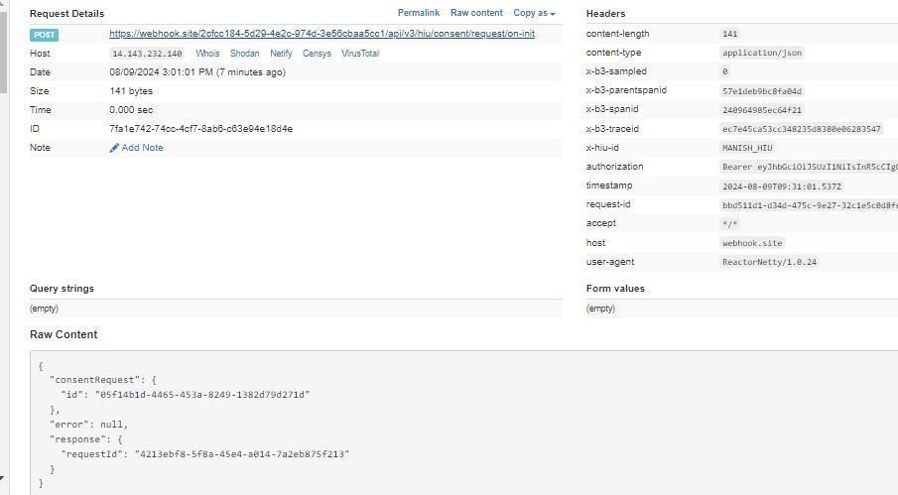

HIE-CM- Callback API to HIU when a consent request is APPROVED/REVOKED/DENIED
Once the patient grants consent to the HIU, the CM notifies the HIU system of the consent grant via the gateway. If the patient grants for multiple HIPs, then multiple consent artefacts are generated - one for each HIP. The HIU now first fetches all the consentartefacts that were generated for his request.
URL: {{callback}} /api/v3/hiu/consent/request/notify Request: POST Header Parameters:
Property Name | Example Value | Required | Description
REQUEST-ID | 18235d89-cb13-479d-ad71-  7a57d5f669a8 | Yes | Unique UUID for track the end to end request transaction
TIMESTAMP | 2022-10-06T10:10:00.587Z | Yes | Actual time when request was initiated, ISO Date time format represents date and time
X-HIU-ID | eyJhbGciOiJSUzUxMiJ9.eyJzdWIiOiIx  ODQ0MzgxMDgwNjQ0MEBhYmRt | Yes | Identifier to the health information user.
Body parameters:
Property Name | Example Value |  | Required | Description
status | GRANTED | Yes |  | The status of the consent artefact
consentRequestId | 3fa85f64-5717-4562b3fc-  2c963f66afa6 | Yes |  | The consent request  id
reason | Not Authorized | No |  | Reason for denying the consent request
consentArtefacts | "consentArtefacts": [  {  "id": “3fa85f64- 5717-4562-b3fc-  2c963f66afa6”  }  ] | No |  | List of consent artefact ids that was created
Request Body:
Request Body:
{
"notification": { "consentRequestId": "e3c74829-3f82-4f94-959e-e10f57bcd57b", "status": "GRANTED",
"reason": null,
"consentArtefacts": [
{
"id": "<consent-artefact-id>"
}
]
} }

Response Body:
Response
Status: 202 Accepted

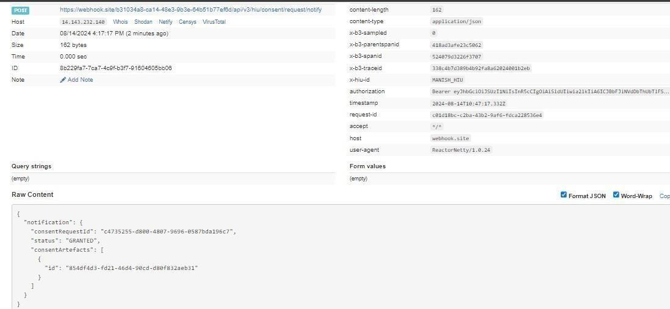

HIE-CM – API for HIU to respond back to consent HIU callback
This API will be invoked by HIU to respond back to HIE-CM when they received notify call after approve /deny / revoke.
/api/v3/hiu/consent/request/notify.
URL: /api/hiecm/consent/v3/request/hiu/on-notify Request: POST
Header Parameters:
Property Name | Example Value | Required | Description
REQUEST-ID | 18235d89-cb13-479d-ad71-  7a57d5f669a8 | Yes | Unique UUID for track the end to end request transaction
TIMESTAMP | 2022-10-06T10:10:00.587Z | Yes | Actual time when request was initiated, ISO Date time format represents date and time
X-CM-ID | sbx | Yes | Suffix of the consent manager to which the request was intended

Body parameters:
Property Name | Example Value |  | Required | Description
status | OK | Yes |  | The status of the consent notify.
consentId | 3fa85f64-5717-4562b3fc-  2c963f66afa6 | Yes |  | The consent artefact  id
error | "error": {  "code": "ABDM-1001", "message": "unable to connect database"  } | No |  | The error code and message if any happened.
requestId | 3fa85f64-5717-4562b3fc-  2c963f66afa6 | Yes |  | The request id from the  /hiu/consent/request/notify
Request Body:
Request Body:
{
"acknowledgement": [
{
"status": "OK",
"consentId": "e3c74829-3f82-4f94-959e-e10f57bcd57b"
}
],
"error": {
"code": "ABDM-1001",
"message": "unable to connect database"
},
"response": {
"requestId": "6f0b4665-a915-4c92-aa36-65afb4a2cd71"
} }
Response Body:
Response
Status: 202 Accepted

Error Scenarios:
Scenarios | Headers/Body | Message

To verify when Request ID is Blank, null or empty in header | [  {  "key": "REQUEST-ID",  "value": "",  "type": "text"  }  ] | Access Denied  Code : 403 Forbidden
To verify when invalid Request-ID is pass in header | [  {  "key": "REQUEST-ID",  "value": "{{$guid}}zxzzxs",  "type": "text"  }  ] | {  "code": "ABDM-1030: ",  "message": "Invalid requ est  ID" }  Code - 400Bad Request
When Timestamp is Blank, null or empty in header. | [  {  "key": "TIMESTAMP",  "value": "",  "type": "text"  }  ] | Access Denied  Code : 403 Forbidden
When invalid Timestamp is pass in header | [  {  "key": "TIMESTAMP",  "value": "{{$isoTimestamp}}jhgftytgtyu",  "type": "text"  }  ] | {  "code": "ABDM-1016: ", "message": "Invalid Time stamp"  }  Code - 400Bad Request
To verify when X- CM-ID is Blank, null or empty in header | [  {  "key": " X-CM-ID",  "value": "",  "type": "text"  }  ] | Access Denied  Code : 403 Forbidden

HIE-CM- Consent request status
This API will be called to get the status of the consent request.
URL: /api/hiecm/consent/v3/request/status Request: POST Header Parameters:
Property Name | Example Value | Required | Description
REQUEST-ID | 18235d89-cb13-479dad71-  7a57d5f669a8 | Yes | Unique UUID for track the end to end request transaction
TIMESTAMP | 2022-10-06T10:10:00.587Z | Yes | Actual time when request was initiated, ISO Date time format represents date and time.
Authorization | Gateway Session Token | Yes | JWT Access token which was issued by ABDM session API after successful validation of client id and secret
X-HIU-ID | HIU_ID | Yes | Identifier of the health information user to which the request was intended

Body Paramaters:
Property Name | Example Value | Required | Description
consentRequestId | 18235d89-cb13-479dad71-  7a57d5f669a8 | Yes | Unique UUID for consent request
Request Body:
 |  |  | Request Body:
 | {  } |  | "consentRequestId": "05f14b1d-4465-453a-8249-1382d79d271d"
Response Body:
Response
Code : 200 OK

Error scenarios:

Scenarios | Headers/Body | Message
To verify when  Request ID is Blank, null or empty in header | [  {  "key": "REQUEST-ID",  "value": "",  "type": "text"  }  ] | Access Denied  Code : 403 Forbidden
To verify when invalid RequestID is pass in header | [  {  "key": "REQUEST-ID",  "value": "{{$guid}}zxzzxs", "type": "text"  }  ] | {  "code": "ABDM-1030: ",  "message": "Invalid request ID"  }  Code - 400Bad Request

When  Timestamp  is Blank, null or empty in header. | [  {  "key": "TIMESTAMP", "value": "",  "type": "text"  }  ] | Access Denied  Code : 403 Forbidden

When invalid Timestamp is pass in header | [  {  "key": "TIMESTAMP",  "value": "{{$isoTimestamp}}jhgftytgtyu",  "type": "text"  }  ] | {  "code": "ABDM-1016: ",  "message": "Invalid Timestamp"  }  Code - 400Bad Request
When X-CM-  ID is Invalid,  Blank, null or empty in header. | [  {  "key": "X-CM-ID",  "value": "sbxdvdfvdf",  "type": "text"  }  ] | Access Denied  Code : 403 Forbidden
When X-HIU- ID is Blank, null or empty in header. | [  {  "key": "X-HIU-ID",  "value": "",  "type": "text"  }  ] | Access Denied  Code : 403 Forbidden
When passing  invalid  Consent  Request Id | {  "consentRequestId": "002e14ac-13"  } | Callback : {  "error": {  "code": "ABDM-1039: ",  "message": "Invalid Consent req uest id"  },  "response": {  "requestId": "fe717659-f438- 4bda-8f7c- 0ba13e9c5f61"  }  }  code - 200 OK
When passing Null Consent  Request Id | {  "consentRequestId":null  } | [  {  "code": "ABDM-9999: ",  "message": "Invalid Consent req uest id"  }  ]  Code - 400Bad Request
When body  missing |  | {  "code": "ABDM-1064",  "message": "Request body was mis sing"  }  Code - 400Bad Request

HIE-CM - Consent request on-status (Callback)
This API is used to send the status of consent request back to HIU through HIE-CM URL: {callback_url}/api/v3/hiu/consent/request/on-status Request: POST Header Parameters:
Property Name | Example Value | Required | Description
REQUEST-ID | 18235d89-cb13-479dad71-  7a57d5f669a8 | Yes | Unique UUID for track the end to end request transaction
TIMESTAMP | 2022-10-06T10:10:00.587Z | Yes | Actual time when request was initiated, ISO Date time format represents date and time.
X-HIU-ID | HIU_ID | Yes | Identifier of the health information user to which the request was intended
Authorization | Gateway Session Token | Yes | ABDM Gateway Session Token
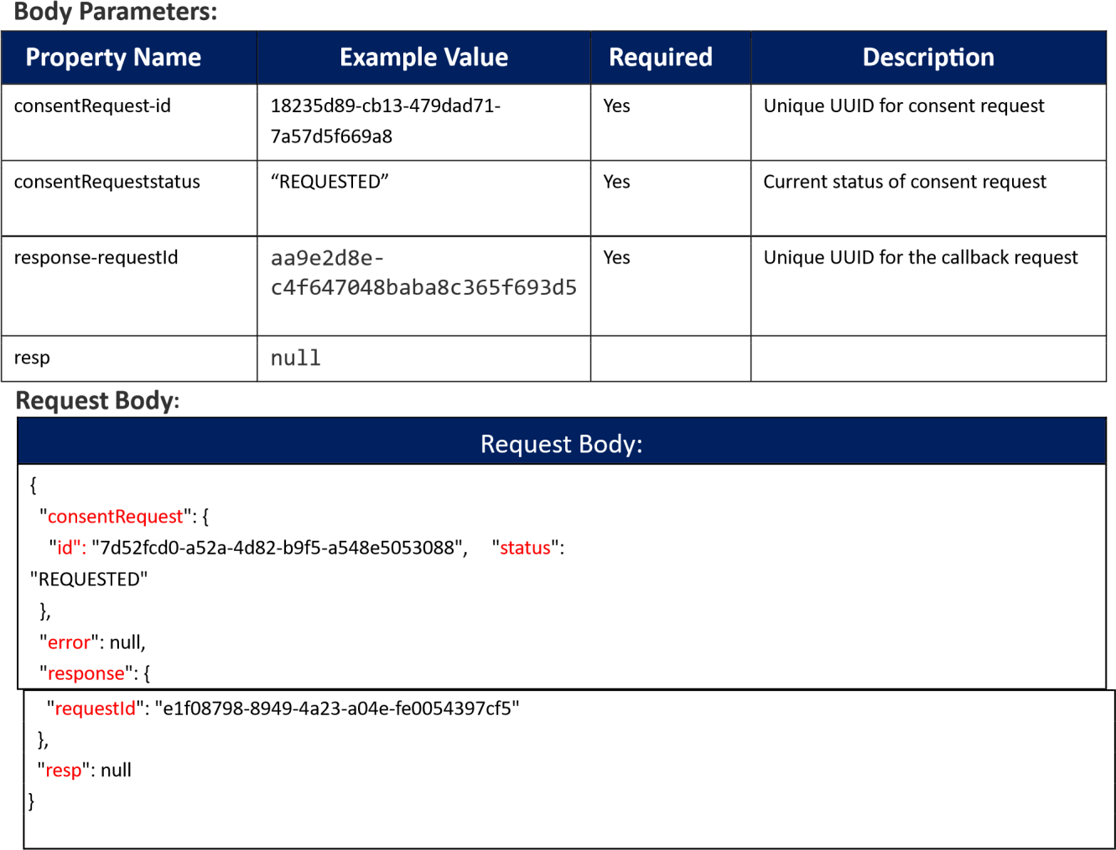

Response Body: The table below illustrates the response body

Response
Code : 200 OK
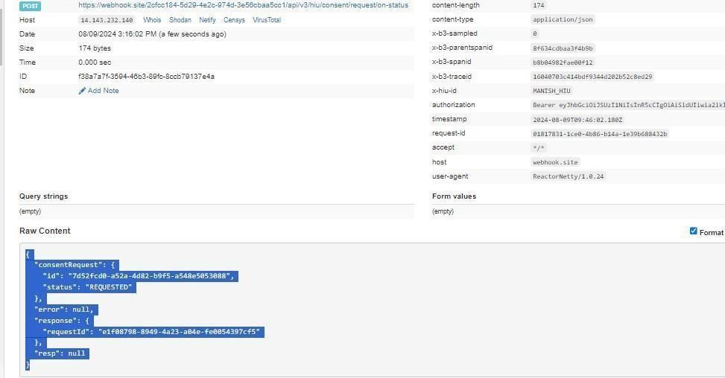

HIE-CM - Consent request fetch
This API will be called to fetch the consent artifact details.
URL: /api/hiecm/consent/v3/fetch
Request: POST
Header Parameters:
Property Name | Example Value | Required | Description
REQUEST-ID | 18235d89-cb13-479dad71-  7a57d5f669a8 | Yes | Unique UUID for track the end to end request transaction
TIMESTAMP | 2022-10-06T10:10:00.587Z | Yes | Actual time when request was initiated, ISO Date time format represents date and time
X-CM-ID | sbx | Yes | Suffix of the consent manager to which the request was intended
X-HIU-ID | HIU_ID | Yes | Health information user unique ID
Authorization | Gateway Session Token | Yes | JWT Access token which was issued by ABDM session API after successful validation of client id and secret
Body parameters:
Property Name | Example Value | Required | Description
consentId | 18235d89-cb13-  479d-ad717a57d5f669a8 | Yes | Unique UUID of the validate the consent to share the data between HIP and HIU
Request Body:
Request Body:
{
"consentId": "d6a83f24-6c96-421e-b8b8-844e5344ef69"
}
Response Body:
Code : 202 OK
Error Scenarios:
Scenarios | Headers/Body | Message
To verify when  Request ID is Blank, null or empty in header | [  {  "key": "REQUEST-ID",  "value": "",  "type": "text"  }  ] | Access Denied  Code : 403 Forbidden

To verify when  invalid  Request-ID is pass in header | [  {  "key": "REQUEST-ID",  "value": "{{$guid}}zxzzxs",  "type": "text"  }  ] | {  "code": "ABDM-1030: ",  "message": "Invalid request ID"  }  Code - 400Bad Request
When  Timestamp  is Blank, null or empty in header. | [  {  "key": "TIMESTAMP", "value": "",  "type": "text"  }  ] | Access Denied  Code : 403 Forbidden
When  invalid  Timestamp is pass in header | [  {  "key": "TIMESTAMP",  "value": "{{$isoTimestamp}}jhgftytgtyu",  "type": "text"  }  ] | {  "code": "ABDM-1016: ",  "message": "Invalid Timestamp"  }  Code - 400Bad Request
When X- CM-ID is Invalid,  Blank, null or empty in header. | [  {  "key": "X-CM-ID",  "value": "sbxdvdfvdf",  "type": "text" | Access Denied  Code : 403 Forbidden

}
]
When X- HIU-ID is Blank, null or empty in header. | [  {  "key": "X-HIU-ID",  "value": "",  "type": "text"  }  ] | Access Denied  Code : 403 Forbidden
When passing invalid Consent artefact Id | {  "consentId": "1769c167-0898-43"  } | Callback : {  "error": {  "code": "ABDM-1080: ",  "message": "Invalid Consent artefa ct id"  },  "response": {  "requestId": "7c4c31dadfd04348a907c08ea4016cbe"  }  }  code - 200 OK
When passing Null Consent artefact Id | {  "consentId": null  } | [  {  "code": "ABDM-9999: ",  "message": "Invalid Consent artefa ct id"  }  ]  Code - 400Bad Request
When body  missing |  | {  "code": "ABDM-1064",  "message": "Request body was missi ng"  }  Code - 400Bad Request

HIE-CM - Consent request on-fetch (callback)
This API is used to send the consent artifact details to HIU through HIE-CM URL: {callback_url} /api/v3/hiu/consent/on-fetch Request: POST Header Parameters:
Property Name | Example Value | Required | Description
REQUEST-ID | 18235d89-cb13-479dad71-  7a57d5f669a8 | Yes | Unique UUID for track the end to end request transaction
TIMESTAMP | 2022-10-06T10:10:00.587Z | Yes | Actual time when request was initiated, ISO Date time format represents date and time
X-HIU-ID | HIU_ID | Yes | Health information user unique ID
Authorization | Gateway Session Token | Yes | ABDM Gateway Session Token
Body parameters:
Property Name | Example Value | Require d | Descriptio n
Status | GRANTED | Yes | Current status consent request
consentId | 18235d89-cb13-479d-ad71-7a57d5f669a8 | Yes | Consent  artefact id
Hip | ABDM_HIP | No | Health information provider ID

Patient-id | user@abdm | Yes | The abha address
Purpose-text | Care Management | Yes | Purpose text of consent request
Purpose-code | CAREMGT | Yes | Purpose code of consent request
Purpose-refUri | www.test.com | Yes | Purpose refUri of consent request
patientReference | batman@tmh | No | Patient reference  Id
careContextReference | Episode11 | No | Care context reference
hiu | HIU_ID | Yes | Health information user Id

Requester-name | Smith | Yes | Name of the requester
Requester-identifiertype | REGN01 | Yes | Requester  identifier type
Requester-identifiervalue | MH1001 | Yes | Requester  identifier value
Requester-identifiersystem | https://www.mciindia.org | Yes | Requester identifier system

hiTypes | ["Prescription",  "DiagnosticReport",  "DischargeSummary  "ImmunizationRecord",  "HealthDocumentRecord",  "WellnessRecord",  "OPConsultation"] | Yes | Type of document
PermissionaccessMode | VIEW | Yes | Access mode of consent
PermissiondateRange | "from": "2023-05-09T08:58:09.738Z",  "to": "2023-05-10T08:58:09.738Z" | Yes | Data range of permission required
PermissiondateEraseAt | 2023-05-25T08:58:09.738Z | Yes | Date of erase data
Permissionfrequency-value | 0 | Yes | Frequency value for consent
Permissionfrequencyrepeats | 0 | Yes | Frequency repeats for consent
Permissionfrequency-unit | HOUR | Yes | Frequency unit for consent
createdAt | 2023-05-25T08:58:09.738Z | Yes | The date consent artefact created
lastUpdated | 2023-05-25T08:58:09.738Z | Yes | The date consent artefact last updated.
schemaVersion | v3 | Yes | Version
Signature | bAJUnf7nY6Yn6A7JbR1ZFHtBmqCjXDW  ZaQte  F+XNgEImUchTgA4qp4i5KnUBXYsWuTK  Be  USf1cLFMUXGpQuD9OZzrMqA1PRnEWyh  0  lV9i1bsEm5VMBkeZa0ghQBc4Fj8g== | Yes | Signature of consent aretefact
response-requestId | 36de611a-c3ab-4794-b803-  5eff9c94ddbf | Yes | Unique UUID for call back request
Request Body:
Request Body:
{
"consent": {
"status": "GRANTED",
"consentDetail": {
"consentId": "d6a83f24-6c96-421e-b8b8-844e5344ef69",
"hip": {
"id": "HIP_ID"
},
"hiu": {
"id": "HIU_ID"
},
"hiTypes": [
"Prescription",
"DiagnosticReport",
"DischargeSummary",
"ImmunizationRecord",
"HealthDocumentRecord",
"WellnessRecord",
"OPConsultation"
],
"patient": {
"id": "xxxxxx@sbx"

},
"purpose": {
"text": "Care Management", "code":
"CAREMGT",
"refUri": "www.abdm.gov.in"
},
"createdAt": "2024-08-09T05:00:03.265Z",
"requester": {
"name": "Dr. Manju",
"identifier": {
"value": "MH1001",
"type": "REGNO",
"system": "https://www.mciindia.org"
}
},
"permission": {
"accessMode": "VIEW",
"dateRange": {
"from": "1924-07-09T12:05:57.151Z",
"to": "2024-07-17T12:05:57.151Z"
},
"dataEraseAt": "2124-12-09T00:00:00.000Z",
"frequency": {
"unit": "DAY",
"value": 1,
"repeats": 0
}
},
"lastUpdated": "2024-08-09T05:00:03.144Z",
"careContexts": [
{
"patientReference": "xxxxxxx@sbx",
"careContextReference": "COCa496bc2f-ca6c-4af5-b973-02e915fd9815"
}
],
"schemaVersion": "v3",
"consentManager": {
"id": "sbx"
}
},
"signature": "pktEFkcXuMBPSCEb7ZbiRAOigEx3i5fvIVNS9CxAfgm7rRF9CoxyhO0OdX9Fe
CzmcobBeiqNdLkiX2eYXdTI1oWvvEnSgMYBXVRi4q9rUgXexJr+04QK6vk4lL2iwu6AfKqPTB8u
3LF4v5kmCTXqdmtlfRof+ue9avukW48yIij19okHYhTw2lOZQ=="
},
"error": null,
"response": {
"requestId": "c0027971-d2d3-4323-8353-881b7c8f7d2f"
},
"resp": null
}

Response Body:
Response
Code : 200 OK
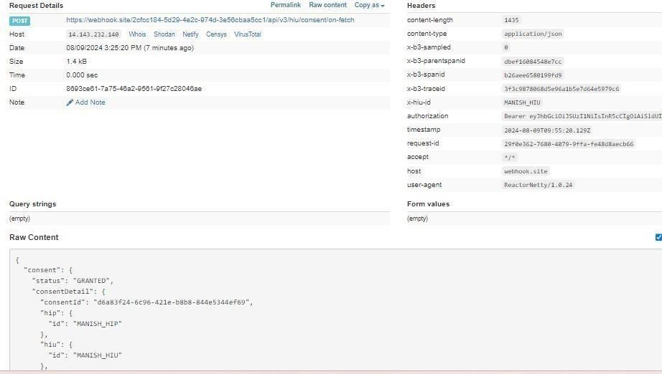
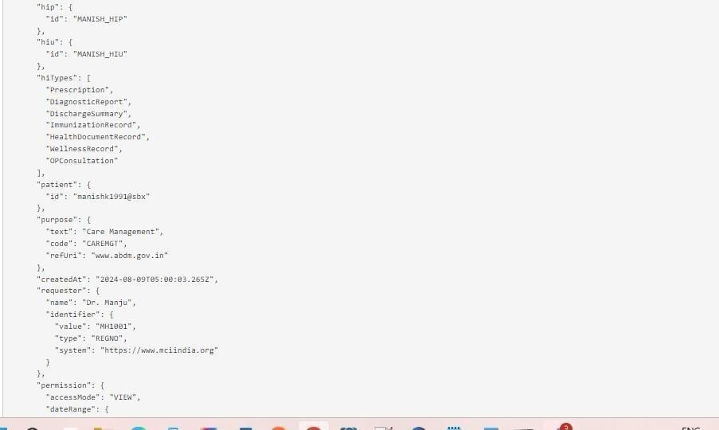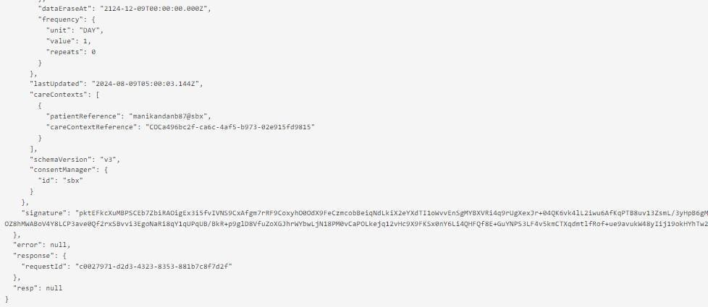

Data flow

Overview
The process of Data flow starts once the HIECM has generated Consent artefact (Consent artefact is generated only if the status of Consent request is “Granted”) and same is notified to HIP and HIU.
HIU sends pushback URL to HIP via HIECM. HIP now bundles the care context or Health data of the patient as per FHIR standards and share the data via pushback data URL.
HIECM is notified the status of the data shared both by HIU and HIP.

Sequence Diagram

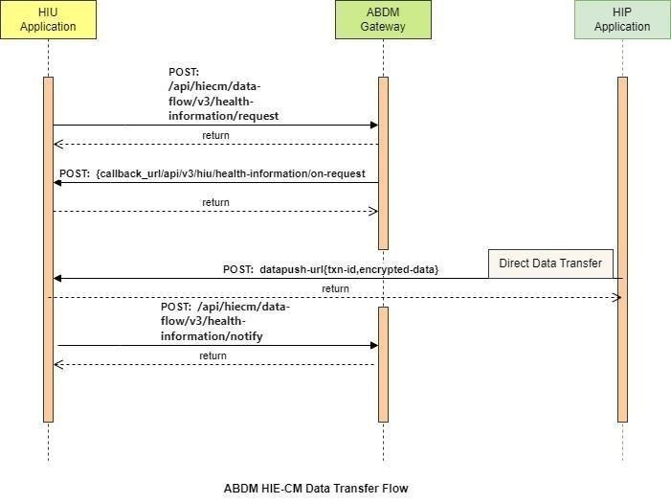

API Information Request & Response

Data flow – Data request invoked by HIU
The HIU system initiates data request for a patient’s health information to the HIP against the relevant consent-artefact, through the CM.
As part of the data request, the HIU’s health repository embeds three key elements within the health information request:
The consent ID corresponding to the consent artefact against which the information request is being made.
A data push URL, which is a callback URL that indicators where the information can be pushed by the HIP’s health repository. This URL can be different from the HIU’s access URL, provided at the time of registration with the gateway. The HIU can specify a different URL for the data flow, in order to keep its identity secret to the extent possible.
Several parameters such as the date-time range for the requested and a set of encryption parameters for the HIP repository to encrypt the information. The Elliptic-curve Diffie– Hellman based encryption standard is used for encrypting health information.
Upon receipt of the data-request, CM assigns a transaction ID (txn-id) for the entire data flow and communicates this Id to the health repositories of the HIU and the HIP.
The HIU’s health repository relays all this information to the CM through the gateway.
From the CM, the information is relayed to the HIP’s health repository (via the HIE-CM).
URL: /api/hiecm/data-flow/v3/health-information/request
Request: POST
Header Parameters: The table below illustrates the header parameters
Property  Name | Example Value | Required | Description
Authorization | Gateway Session Token | Yes | JWT Access token which was issued by ABDM session API after successful validation of client id and secret
REQUEST-ID | b22bc4a6-7894-431e-9d800e289610d0f8 | Yes | Unique UUID for track the endtoend request transaction
TIMESTAMP | 2024-08-09T05:07:17.151Z | Yes | Actual time when request was initiated, ISO Date time format represents date and time
X-CM-ID | sbx | Yes | Suffix of the consent manager to which the request was intended
X-HIU-ID | HIU_ID | Yes | Identifier of the health information user by which the request was initiated
Body Parameters:
The table below illustrates the body parameters

Property  Name | Example Value | Required | Description
Consent ID | 18235d89-cb13-479d-ad71-7a57d5f669a8 | Yes | Valid consent ID, which HIU must obtain to request patient data from a  HIP
DateRange | [  {  "from": "1924-07-09T12:05:57.151Z",  "to": "2024-07-17T12:05:57.151Z"  } ] | Yes | Date Range against which the consent granted will be validated.
DataPushUrl | https://webhook.site/2cfcc184-5d29-  4e2c974d3e56cbaa5cc1/v3/data/push | Yes | This is the URL provided by HIU to which HIP has to push the requested health information record
cryptoAlg | “ECDH” |  | ECDH is a key sharing algorithm, most commonly used to send encrypted messages.  ECDH works by multiplying your private key by another's public key to get a shared secret, then using that shared  secret to perform symmetric encryption
curve | “curve25519” | Yes | Key exchanges authentication
expiry | 2124-12-09T00:00:00.000Z | Yes | Actual time by when dataPushUrl is available
parameters | “Ephemeral public key” | Yes | Encryption and decryption key
keyValue | BFN7KTdOT0jIAExG2A8Jg+01w  MPWxptiGqwHRVvtiVEsUq2FR7P2  UdqZxJyPJSeR6muai21iQhasNxnhh8I5M+g=" | Yes | key agreement protocol that allows two parties, each having an  ellipticcurve public–private key pair, to establish a shared secret over an insecure channel
Request Body: The table below illustrates the request body
Request Body

{

"
hiRequest
": {

"
consent
": {

"
id
": "004ff8e6
-
a9d7
-
4963
-
822
b
-
d9762179314e"

}
,

"
dateRange
": {

"
from
": "1924
-
07
-
09
T12:05:57.151Z",

"
to
": "2024
-
07
-
T12:05:57.151Z"
17

,
}

"
dataPushUrl
": "https://webhook.site/2cfcc184
-
5
d
29
-
e2c
4
-
974
d
-
3
e56cbaa5cc1/v3/data/push",

"
keyMaterial
": {

"
cryptoAlg
": "ECDH",

"
curve
": "Curve25519",

"
dhPublicKey
": {

"
expiry
": "2124
-
11
-
09
T00:00:00.000Z",

"
parameters
": "Curve25519/32byte random key",

"
keyValue
":

"BCpsBW37KgfLyjxJK0zHHG26hDjxzK368DEO4PapzFhQM0cghZziKuvJh5/anTnHitVHKMn0Owr1HvcH1fm0D pA="

,
}

"
nonce
": "0ka0stPfqmXWhX+ODC/iOFMO0PXFdRjBdcEGbv55qqc="

}

}

}

Response Body: The table below illustrates the response body
Response
Code : 202 Accepted

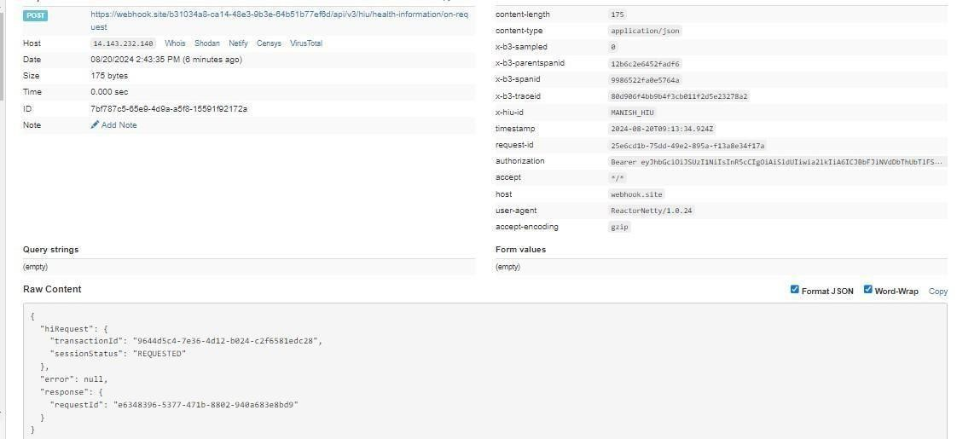

Data flow – call back to HIU
This is the callback API for acknowledgment of Health information request of HIU. CM calls this API when it has validated the Health Information request given the consent id. Either the hiRequest or error would need to be specified. If the health info request was valid, then the hiRequest.transactionId specifies the transaction context against which HIP would send over the data.
URL: {callback_url/api/v3/hiu/health-information/on-request
Request: POST
Header Parameters: The table below illustrates the header parameters
Property Name | Example Value | Required | Description
REQUEST-ID | 18235d89-cb13-479d-ad71-  7a57d5f669a8 | Yes | Unique UUID for track the end to end request transaction
TIMESTAMP | 2022-10-06T10:10:00.587Z | Yes | Actual time when request was initiated, ISO Date time format represents date and time
X-HIU-ID | HIU_ID | Yes | Identifier of the health information  user by which the request was  initiated
Authorization | Gateway Session Token | Yes | ABDM Gateway Session Token

Body Parameters: The table below illustrates the body parameters
Property Name | Example Value | Required | Description
transactionId | 18235d89-cb13-  479dad71-7a57d5f669a8 | Yes | Unique UUID for track the end to end request transaction
sessionStatus | “REQUESTED” | Yes | Status of data transfer request
requestId | “f29f0e59-8388-4698-  9fe6-05db67aeac46” | Yes | Unique UUID received from HIU while initiating the following  hiecm/api/v3/dataflow/healthinformation/request

Request Body: The table below illustrates the request body
Request Body:
{
"hiRequest": {
"transactionId": "3332b62a-1cae-454f-a278-aaf80724f2b6",
"sessionStatus": "REQUESTED"
},
"error": null,
"response": {
"requestId": "b22bc4a6-7894-431e-9d80-0e289610d0f8"
}
}

Response Body: The table below illustrates the request body
Response
Code : 200 OK

Error Scenario:
{
"error": {
"code": "ABDM-1092",
"message": " Invalid or already expired consent artefact id "
},
"response": {
"requestId": "b07737a8-1c79-48cc-9fb4-1476c6bb1197"
}
}

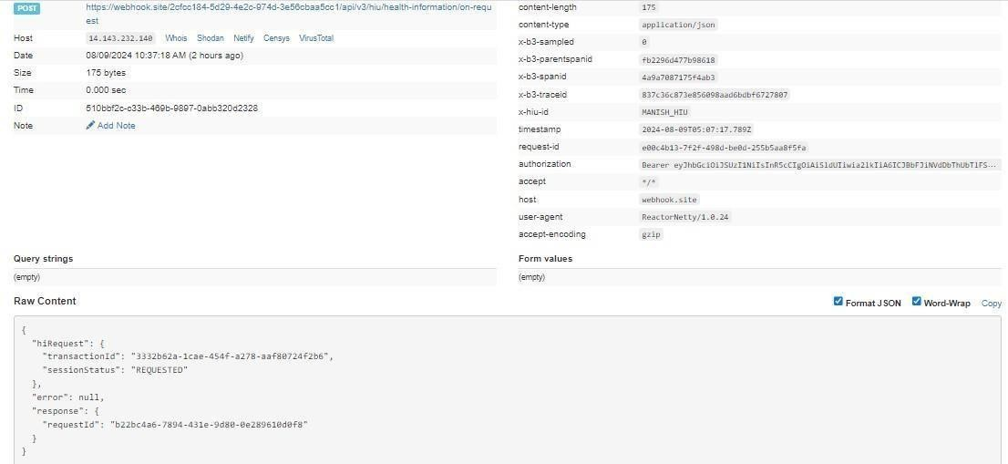

Response
Code : 202 Accepted

Notify
This API will be called by HIU and HIP to notify the CM about the status of the data transfer.

HIP on the transfer of data would send sessionStatus - one of [TRANSFERRED, FAILED]. HIP would also send hiStatus for each careContextReference - on of [DELIVERED, ERRORED]

HIU on receipt of data would send sessionStatus - one of [RECEIVED, FAILED]. For example, ERRORED when data was not sent or if invalid data was sent. HIU would also send hiStatus for each careContextReference - one of [OK, ERRORED].
URL: /api/hiecm/data-flow/v3/health-information/notify
Request: POST

Header Parameters: The table below illustrates the header parameters
Property Name | Example Value | Required | Description
REQUEST-ID | 18235d89-cb13-479dad71-  7a57d5f669a8 | Yes | Unique UUID for track the end to end request transaction
TIMESTAMP | 2022-10-06T10:10:00.587Z | Yes | Actual time when request was initiated, ISO  Date time format represents date and time
X-CM-ID | sbx | Yes | Suffix of the consent manager to which the request was intended
Authorization | Gateway Session Token | Yes | JWT Access token which was issued by ABDM session API after  successful validation of client id and secret
Body parameters: The table below illustrates the body parameters
Property Name | Example Value | Required | Description
consentId | 7497e59e-fa17-4be3b0b3-  5afe4f3b5136 | Yes | Unique UUID of the validate the consent to share the data between HIP and HIU
transactionId | 87624e00-21b5-43b1-  8ae7-5adcb743ef7b | Yes | Unique UUID for track the end to end request transaction
doneAt | 024-08-09T08:06:07.883Z | Yes | Actual time when notification is sent
Notifier | [  {  "type": "HIU",  "id": HIU_ID”  } ] | Yes | Entity who is notifying HIE-CM
statusNotification | {"sessionStatus":  "TRANSFERRED",  "hipId": “HIP_ID",  "statusResponses": [{  "careContextRefer ence": "9ec54c2f-  2f3541d6982846a93e83564e",  "hiStatus": "OK",  "description": "Care  Management"}]} | Yes | Detail about the status of the transaction will be sent in this section by HIP/HIU.
sessionStatus | “TRANSFERRED” | Yes | HIU on receipt of data would send sessionStatus - one of
 |  |  | [TRANSFERRED, FAILED]. For example, FAILED when if data was not sent or if invalid data was sent
hiStatus | "OK", | Yes | HIU would also send hiStatus for each careContextReference - one of [OK, ERRORED]

Request Body: The table below illustrates the request body

{

"
notification
": {

"
consentId
": "97312afb
-
c6a4
-
e
483
-
8456
-
5
c9c96beb83f",

"
transactionId
": "97312afb
-
c6a4
-
483
e
-
8456
-
c9c96beb83f",
5

"
doneAt
": "2024
-
08
-
T08:45:55.984Z",
09

"
notifier
": {

"
type
": "

HIU",

"
id
": "HIU_ID"

,
}

"
statusNotification
": {

"
sessionStatus
": "TRANSFERRED",

"
hipId
": "HIP_ID",

"
statusResponses
": [

{

"
careContextReference
": "9ec54c2f
-
2
f
35
-
41
d
6
-
9828
-
46
a93e83564e",

"
hiStatus
": "OK",

"
description
": "Care Management"

}

]

}

}
}

Response Body: The table below illustrates the response body
Response
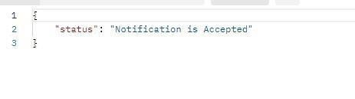Code : 202 Accepted

Subscription flow

Overview
HIU should initiate subscription requests so that it receives notifications/alerts whenever new information is available for the following categories.
- LINK - linking of a new Care-context from HIPs against an ABHA address
- DATA - availability of data against an existing care-context from HIP.
Note: Subscription flow is restricted to the health locker and PHR. Other than health locker and PHR, subscription flow is not authorized.
While seeking subscription HIU needs to use the Gateway Subscription APIs identifying itself as a HIU.
Once user grants subscription to HIU, the HIU will be notified against the subscribed categories.
  - If the subscription category is LINK - HIU should initiate a consent request for the notified care context. Once the user grants the consent against the request, HIU can initiate the data-request.
  - In case subscription category is DATA - then the HIU should check if any existing consent request is available (hiType and duration etc.) and use the same to initiate the data-request.

Sequence Diagram

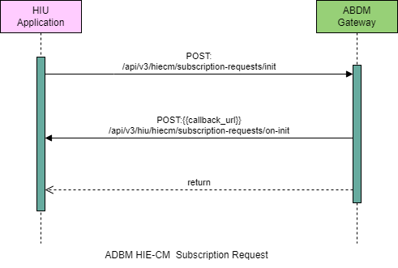

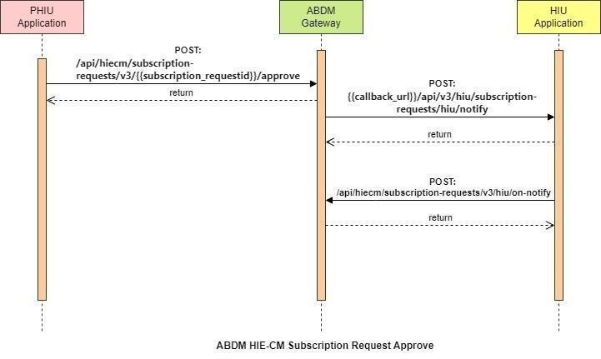

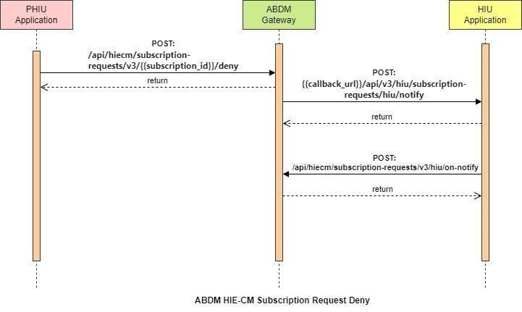

API Information Request & Response

Users get subscription requests
This is an API will be invoked by the patient/user from the PHR application to fetch his/her subscribed HIU details.
URL: /api/hiecm/subscription-requests/v3/requests
Method:
GET Request Headers:
Property  Name | Example Value | Required | Description
Authorization | Gateway Session Token | Yes | JWT Access token which was issued by ABDM session API after successful validation of client id and secret
REQUEST-ID | 18235d89-cb13-479d-ad71-7a57d5f669a8 | Yes | Unique UUID for track the end to end request transaction
TIMESTAMP | 2022-10-06T10:10:00.587Z | Yes | Actual time when request was initiated, ISO Date time format represents date and time
X-AUTHTOKEN | Login Token | Yes | JWT Authentication token which was issued by ABDM after successful validation of  username and password
X-CM-ID | sbx | Yes | Suffix of the consent manager to which the request was intended
Limit | 5 | Yes | How many items to return at one time
Offset | 5 | Yes | How many items out  of line
Filters | “GRANTED” | Yes | Query string parameter restricts the data returned from your request

Body Parameters: Not Applicable Request Body:
Not Applicable Response:

Response:
Code: 202 OK
{
"limit": 5,
"size": 0,
"offset": 5,
"requests": [
{
"requestId": "f29f0e59-8388-4698-9fe6-05db67aeac46",
"subscriptionId": "f29f0e59-8388-4698-9fe6-05db67aeac46",
"requestType": "HEALTH_LOCKER",
"status": "GRANTED",
"details": {
"patient": {
"id": "xxxx@sbx"
},
"purpose": {
"text": "abc@abdm",
"code": "string",
"refUri": "string"
},
"hiu": {
"id": "HIU"
},
"hips": [
{
"id": "HIP"
}
],
"categories": [
"LINK"
],
"period": {
"from": "2023-01-18 05:19:33.429",
"to": "2023-01-18 05:19:33.429"
}
}
}
] }

User subscription request initiate
This is the API which will be invoked by the HIU to initiate subscription request to the patient/user from PHR application
URL: /api/hiecm/subscription-requests/v3/init Method:
Post Request Headers:
Property  Name | Example Value | Required | Description
REQUEST-ID | 18235d89-cb13-  479d-ad717a57d5f669a8 | Yes | Unique UUID for track the end to end request transaction
TIMESTAMP | 2022-10-  06T10:10:00.587Z | Yes | Actual time when request was initiated, ISO Date time format represents date and time
X-CM-ID | sbx | Yes | Suffix of the consent manager to which the request was intended
Authorization | Gateway Session Token | Yes | JWT Access token which was issued by ABDM session  API after successful validation of client id and secret
Body parameters
Property  Name | Example Value | Required | Description
subscription | "purpose": {  "text": "Care Management",  "code": "CAREMGT",  "refUri": "www.abc.com2"  } | Yes | Purpose of Use - defines what is the purpose of use of the health information that a HIU is requesting for. The following are subset from http://terminology.hl7.org/ValueSet/v  3-PurposeOfUse
Patient | "id": "xxxxxxxxx@abdm" | Yes | Patient ABHA address against which the health records are linked
Hiu | "id": "HIU" | Yes
Hips | [  {  "id": "HIP_ID",  "name": "HIP_NAME",  "type": "HIP" } ] | NO
categories | [  "LINK",  "DATA" | Yes | Locker should initiate subscription request so that it receives notifications/alerts whenever new
 | ] |  | information is available for following categories.  - LINK - linking of a new Carecontext from HIPs  - DATA - availability against an existing care-context from HIP
Period | {  "from": "2023-04- 04T09:52:39.235Z",  "to": "2023-0420T09:52:39.235Z"  } | Yes | Period for which the subscription is valid.
Request Body
Request Body:
{
"subscription": {
"purpose": {
"text": "Care Management",
"code": "CAREMGT",
"refUri": "www.abdm.gov.in"
},
"patient": {
"id": "xxxxx@sbx"
},
"hiu": {
"id": "HIU_ID"
},
"hips": [
{
"id": "HIP_ID",
"name": "HIP_NAME",
"type": "HIP"
}
],
"categories": [
"LINK",
"DATA"
],
"period": {
"from": "2024-06-01T09:00:00.000Z",
"to": "2124-12-31T09:00:00.000Z"
}
} }

Response
Response:
Code: 202 Accepted.

User Subscription request initiate – Call Back
This is the API which will be invoked by the HIU to initiate subscription request.
URL: {{call back}}/api/v3/hiu/hiecm/subscription-requests/on-init Method: Post Request Headers:
Property  Name | Example Value | Required | Description
REQUEST-ID | 18235d89-cb13-  479d-ad717a57d5f669a8 | Yes | Unique UUID for track the end-to-end request transaction
TIMESTAMP | 2022-10-  06T10:10:00.587Z | Yes | Actual time when request was initiated, ISO Date time format represents date and time
X-CM-ID | sbx | Yes
Authorization | Gateway Session Token | Yes | ABDM JWT Token
Body parameters
Property  Name | Example Value | Required | Description
subscription Request | {  "id": "34c9b142-8a2c-4f4a- 8d98c305dbdbbcbb"  }
response | {  "requestId": "c8bd00d4-  58d14d888b88a5f0c5817f06"  }

Response TO HIU in call back url
Response:
{
"subscriptionRequest": {
"id": "34c9b142-8a2c-4f4a-8d98-c305dbdbbcbb"
},
"response": {
"requestId": "c8bd00d4-58d1-4d88-8b88-a5f0c5817f06"
} }

Code : 202 Accepted

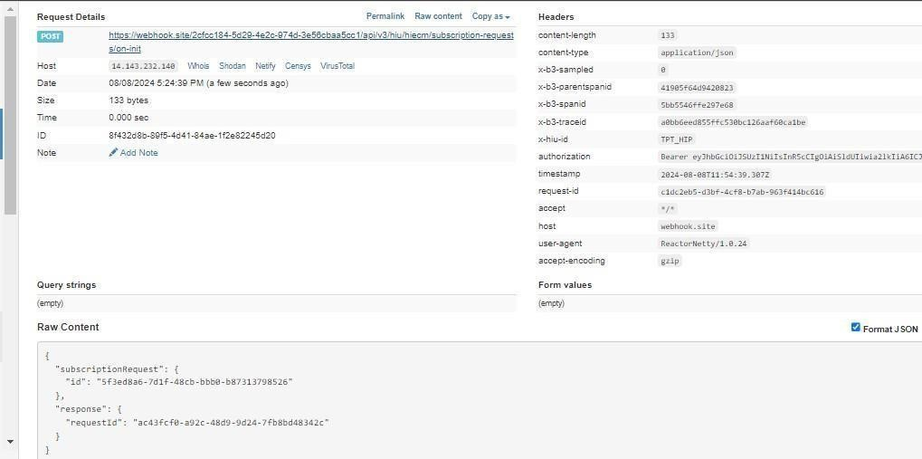

Approve Subscription Request
This Api will be invoked by the patient/user from PHR application to approve the subscription request raised by the HIU
URL: /api/hiecm/subscription- requests/v3/{{subscription_requestid}}/approve Method: Post

Request Headers:
Property Name | Example Value | Required | Description
REQUEST-  ID | 18235d89-cb13-479d-ad71-7a57d5f669a8 | Yes | Unique UUID for track the end to end request transaction
TIMESTAMP | 2022-10-06T10:10:00.587Z | Yes | Actual time when request was initiated, ISO Date time format represents date and time
X-CM-ID | sbx | Yes | Suffix of the consent manager to which the request was intended
X-  AUTHTOKEN | Login JWT Token |  | JWT Authentication token which was issued by ABDM after successful validation of username and password
Authorizati on | Gateway Session Token | Yes | JWT Access token which was issued by ABDM session API after successful validation of client id and secret

Body parameters
Property Name | Example Value | Required | Description
isApplicableForAllHIPs | false | Yes | This value can be false or true. In case of false this will be notified to all the HIPs available in the system and in case of false this will be notified to the specific HIP only
includedSources | [  {  "hiTypes": [  "Prescription",  "DiagnosticReport",  "OPConsultation",  "DischargeSummary",  "ImmunizationRecord",  "HealthDocumentRecord",  "WellnessRecord"  ] | Yes | Included sources will have the list of hi types

Purpose | { | Yes | Purpose for rising the consent
"text": "Care
Management",
"code": "CAREMGT", "refUri":
"www.abc.com7"
}
Hip | [{  "id": "HIP_ID",  "name": "SAI  KRISHNA"  } | Optional | For which HIP consent has been raised
Categories | [  "LINK","DATA"  ], |  | Categories available
Period | {  "from": "2023-04- 04T09:52:39.235Z", "to": "2023-  0420T09:52:39.235Z"  } |  | Period time for approving the subscription

Excluded sources | "excludedSources": [  {  "hiTypes": [  "PRESCRIPTION"  ],  "purpose": {  "text": "Self  Requested",  "code": "PATRQT", "refUri":  "www.test.com"  },  "hip": {  "id": "",  "name": "string"  },  "categories": [  "LINK"  ],  "period": {  "from": "2023-06-  20T05:19:33.429Z",  "to": "2023-06-  30T05:19:33.429Z"  }  }  ] } | Optional | Depending upon the flag selected as  False or True, values need to be added

Request Body
Request Body:

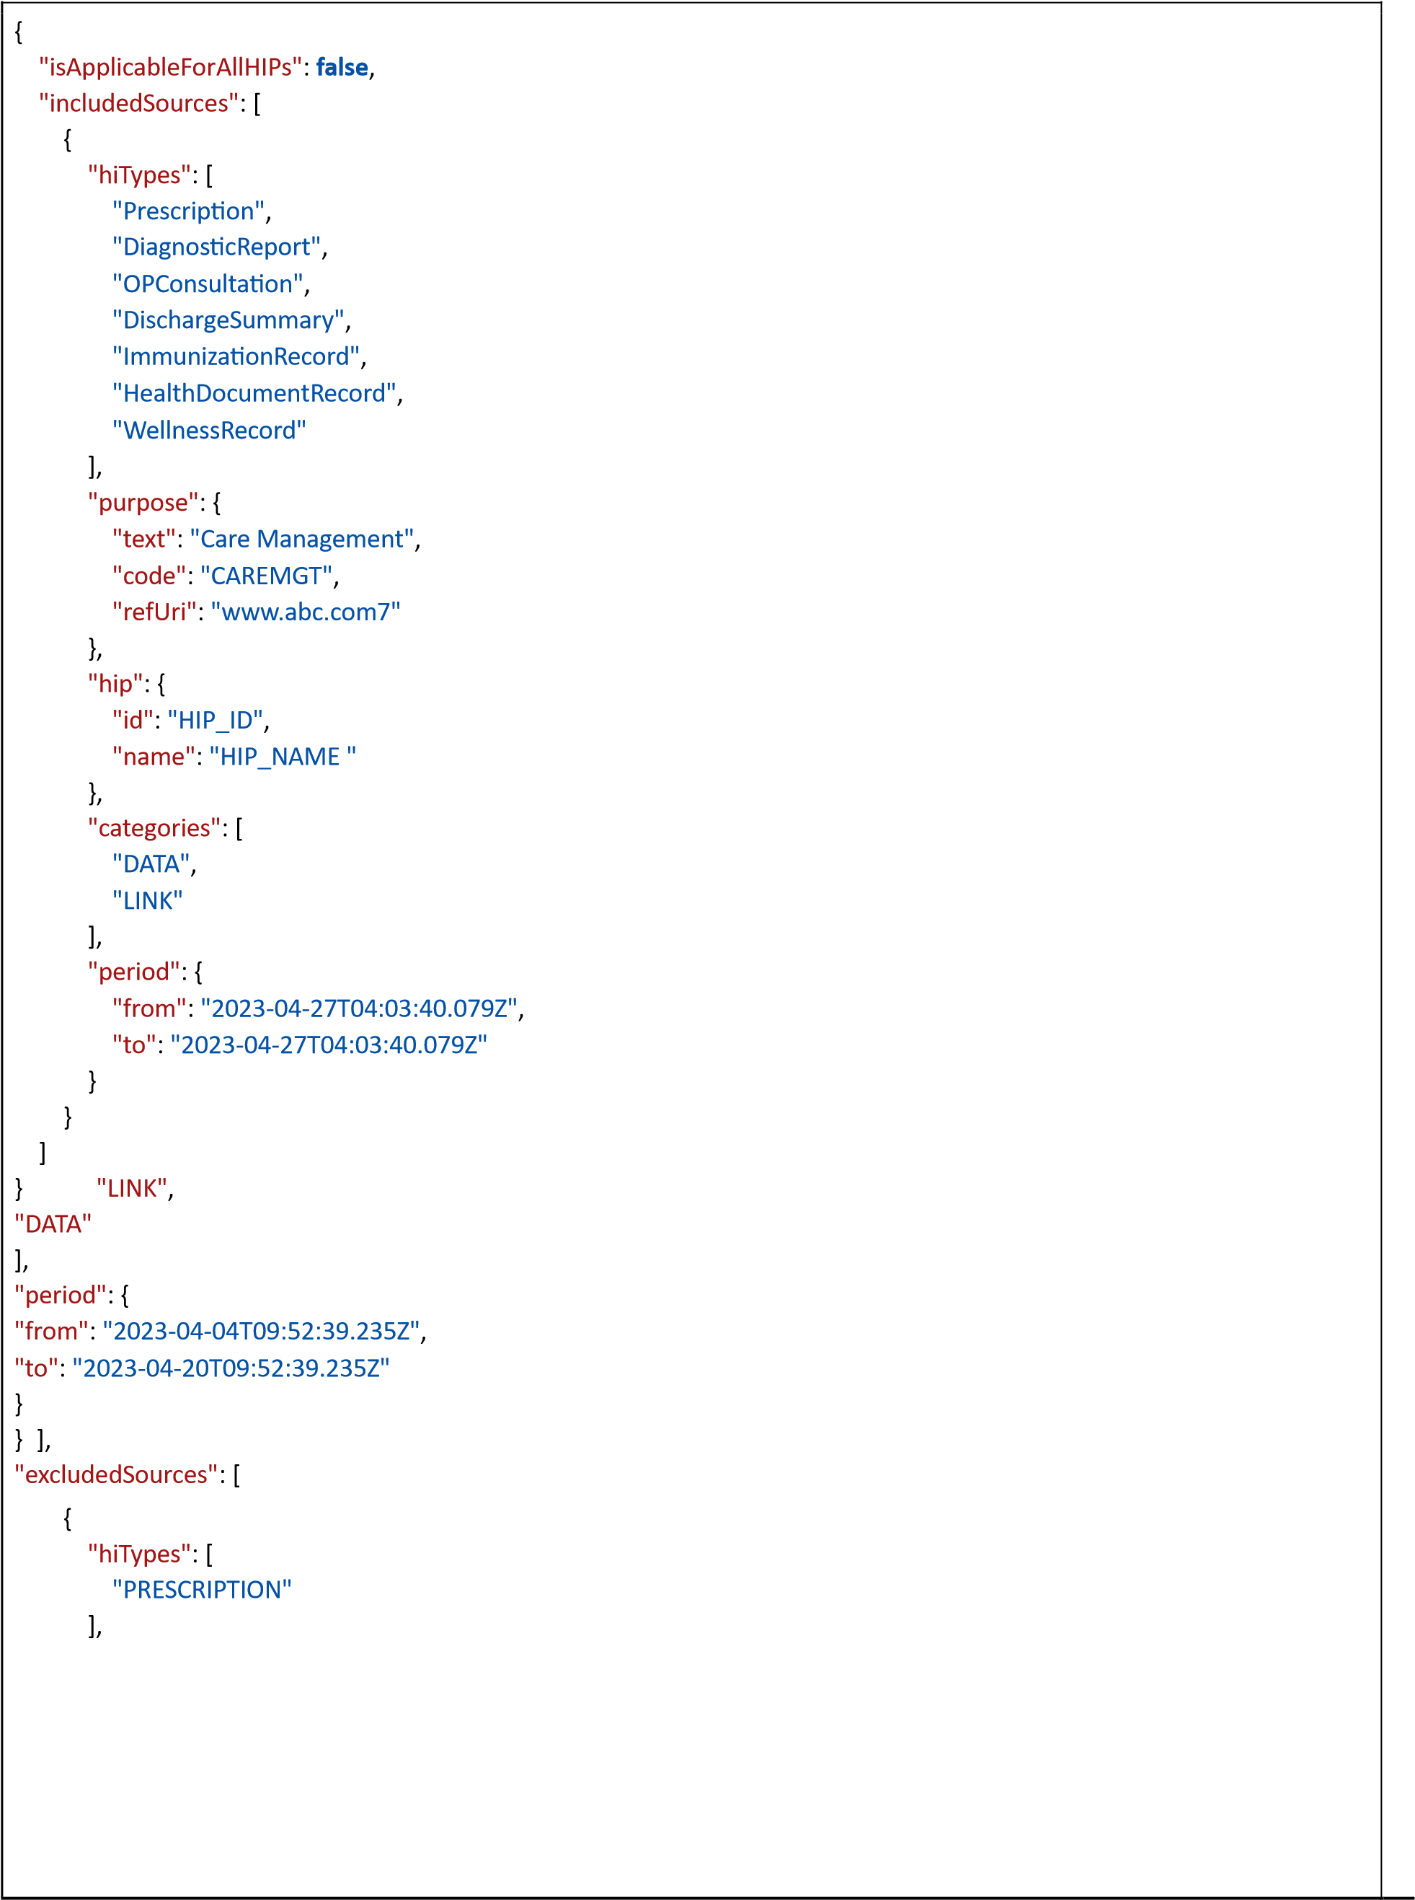
"purpose": {
"text": "Self Requested",
"code": "PATRQT",
"refUri": "www.test.com"
},
"hip": {
"id": "",
"name": "string"
},
"categories": [
"LINK"
],
"period": {
"from": "2023-06-20T05:19:33.429Z",
"to": "2023-06-30T05:19:33.429Z"
}
}
] }

Response
Response:
{
"subscriptionId": "b6c88154-995b-45b0-b720-838e357c8192", "message": "Successfully approved Subscription request"
}
Code: 202 Accepted

Approve Subscription – Call back
URL: {{callback}} /api/v3/hiu/subscription-requests/hiu/notify Method: Post Request Headers:

Property  Name | Example Value | Required | Description
REQUEST-  ID | 18235d89-cb13-479d-ad71-7a57d5f669a8 |  | Unique UUID for track the end to end request transaction
TIMESTAMP | 2022-10-06T10:10:00.587Z |  | Actual time when request was initiated, ISO Date
 |  |  | time format represents date and time
X-CM-ID | sbx |  | Suffix of the consent manager to which the request was intended
Authorizati on | Gateway Session Token |  | ABDM Gateway  Session Token
Body parameters
Property Name | Example Value | Required | Description
SubscriptionRequestId | "57ab7ec0-ce1a-4d408cc3- 66172ac3f6ee",
Status | GRANTED
Subscription | {  "id": "b6c88154-995b-  45b0b720-838e357c8192",  "patient": {  "id": "xxxxxxx@sbx"  },
Hiu | {  "id": "HIP_ID",  "name": "HIP_NAME",  "type": "HIU"  }
Sources | [  {  "hip": {},  "categories": [  "DATA",  "LINK" ]
Period | {  "from": "2023-04- 04T09:52:39.235Z", "to": "2023-  0420T09:52:39.235Z"  }

Response
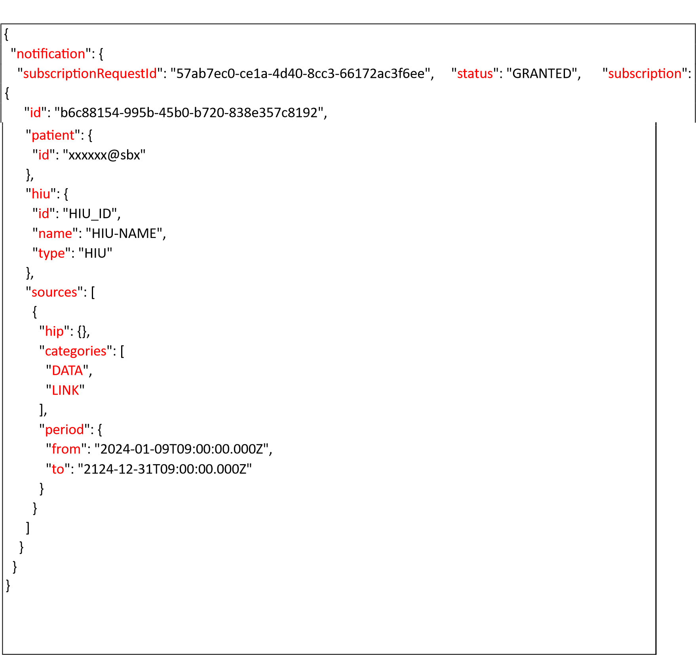

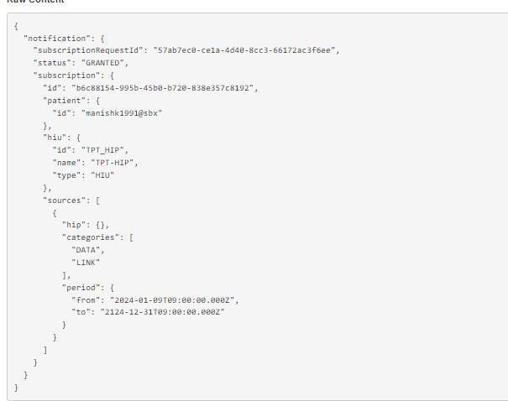

Subscription Request Hiu – on notify
This is the API that will be invoked by the HIU to notify HIECM that HIU has raised the subscription request.
URL: /api/hiecm/subscription-requests/v3/hiu/on-notify Method: Post Request Headers:
Property  Name | Example Value | Required | Description
REQUEST-ID | 18235d89-cb13-479dad71-  7a57d5f669a8 | Yes | Unique UUID for track the end-to-end request transaction
TIMESTAMP | 2022-10-  06T10:10:00.587Z | Yes | Actual time when request was initiated, ISO Date time format represents date and time
X-CM-ID | sbx | Yes | Suffix of the consent manager to which the request was intended
Authorization | Gateway Session Token | Yes | JWT Access token which was issued by ABDM session API after successful validation of client id and secret
Body parameters
Property Name | Example Value | Required | Description
acknowledgement | {  "status": "OK",  "subscriptionRequestId":  "2b8ddd74-5e5e-475b8778-  21603e05a8b4"  } | Yes | 1. This is the  acknowledgement  from the HIU
response | {  "requestId": "a4b51f47f70f-  4291-9599- 8e39b7893cfc"  } | Yes | This is the response ID is used from the initiate request ID
Request Body
Request Body:
{
"acknowledgement": {
"status": "OK",
"subscriptionRequestId": "2b8ddd74-5e5e-475b-8778-21603e05a8b4"
},
"response": {
"requestId": "a4b51f47-f70f-4291-9599-8e39b7893cfc"
}
}
Response
Response:
Code: 202 Accepted

Deny Subscription Request
This API will be invoke by the patient to deny the subscription request raised by the HIU
URL: /api/hiecm/subscriptionrequests/v3/{{subscription_id}}/deny
Method: Post

Request Headers:
Property  Name | Example Value | Required | Description
REQUEST-  ID | 18235d89-cb13-479d-ad71-7a57d5f669a8 | Yes | Unique UUID for track the end to end request transaction
TIMESTAMP | 2022-10-06T10:10:00.587Z | Yes | Actual time when request was initiated, ISO Date time format represents date and time
X-CM-ID | sbx | Yes | Suffix of the consent manager to which the request was intended
X-  AUTHTOKEN | Login JWT Token | Yes | JWT Authentication token which was issued by ABDM after successful validation of username and password
Authorizati on | Gateway Session Token | Yes | JWT Access token which was issued by ABDM session API after successful validation of client id and secret
Body parameters
Property Name |  | Example Value | Required | Description
Reason | False |  | Yes
Request Body
Request Body:
{
"reason": "Not authorized" }

Response
Response:
{
"message": "Successfully denied the subscription request"
}
202 Accepted

Deny Subscription – Call Back
This is the API that will be invoked by the patient to deny the subscription request raise by the HIU
URL: {{ call back}}/api/v3/hiu/subscription-requests/hiu/notify Method: Post Request Headers:
Property  Name | Example Value | Required | Description
REQUEST-  ID | 18235d89-cb13-479d-ad71-7a57d5f669a8 | Yes | Unique UUID for track the end to end request transaction
TIMESTAMP | 2022-10-06T10:10:00.587Z | Yes | Actual time when request was initiated, ISO Date time format represents date and time
X-CM-ID | sbx | Yes | Suffix of the consent manager to which the request was intended
Authorizati on | Gateway Session Token |  | ABDM Gateway Session Token

Body parameters
Property Name | Example Value | Required | Description
notification | {  "subscriptionRequestId":  "5f3ed8a6-7d1f-  48cbbbb0b87313798526",  "reason": "Not required",  "status": "DENIED"  }

Response
Response:
{
"notification": {
"subscriptionRequestId": " 5f3ed8a6-7d1f-48cb-bbb0-b87313798526", "reason": "Not authorized1", "status": "DENIED"
} }
202 Accepted
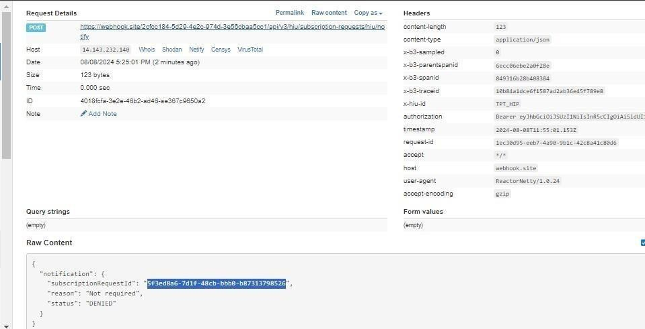

Edit Subscription
This is the API that will be invoked by the patient/user from PHR application to edit the subscription.
URL: /api/hiecm/subscription-
requests/v3/patients/{{approved_subscription_id}} Method: PUT Request Headers:
Property Name | Example Value | Required | Description
REQUEST-ID | 18235d89-cb13-479dad71-  7a57d5f669a8 | Yes | Unique UUID for track the end to end request transaction
TIMESTAMP | 2022-10-06T10:10:00.587Z | Yes | Actual time when request was initiated, ISO 8601 represents date and time by starting with the year, followed by the month, the day, the hour, the minutes, seconds and milliseconds
X-AUTH-TOKEN | Login Token | Yes | JWT Authentication token which was issued by ABDM after  successful validation of username and password
Authorization | Gateway Session Token | Yes | JWT Access token which was issued by ABDM session API after successful validation of client id and secret
X-CM-ID | sbx | Yes | Suffix of the consent manager to which the request was intended

Body Parameters:
 | Property Name | Example Value | Required | Description
hiuId |  | MOHAN-HIU | Yes | HIU who raised the request.

subscriptionEditAndApprovalRequest | "includedSources": [  {  "hiTypes": [  "PRESCRIPTIONs"  ],  "purpose": {  "text": "Care  Management",  "code": "", "refUri":  "www.amazon.com"  }, | Yes | Hi types, purpose should be mentioned while editing the subscription
Hip | {  "id":  "HIP_ID",  "name":  "HIP-NAME" }, | Yes | For which HIP requested was initiated
“categories" | LINK | Yes | Categories can be DATA and LINK
Period | {  "from":  "2023-06-  24T04:03:40.079Z",  "to": "2023-  06-27T04:03:40.079Z"  } | Yes | From when the subscription should be available
excludedSources | [  {  "hiTypes": [  "PRESCRIPTION"  ],  "purpose": {  "text": "Self  Requested",  "code":  "PATRQT",  "refUri":  "www.amazon.com" | optional
},
"hip": {
"id": "HIP-ID",
"name":
"HIP-NAME" },
"categories": [
"LINK"
],
"period": {
"from":
"2023-06-
23T05:19:33.429Z",
"to": "2023-
06-30T05:19:33.429Z"
}
}
]
} }

Request Body:
Request Body:

"hiuId": "HIU_ID",
"subscriptionEditAndApprovalRequest": {
"isApplicableForAllHIPs": true,
"includedSources": [
{
"hiTypes": [
"DiagnosticReport",
"Prescription",
"ImmunizationRecord",
"DischargeSummary",
"OPConsultation",
"HealthDocumentRecord",
"WellnessRecord"
],
"purpose": {
"text": "Care Management", code": "CAREMGT",
"refUri": "www.abdm.gov.in"
},
"categories": [
"DATA",
"LINK"
],
"period": {
"from": "2024-01-09T09:00:00.000Z",
"to": "2123-12-31T09:00:00.000Z"
 |  | }
 | }
]  "  } | ,      excludedSources": []


{

"
}

Response
Response:
Code: 202 Accepted
{
"subscriptionId": "f9ca6ad7-ba8f-4257-b7ad-935a82a94480",
"message": "Successful creation of Subscriptions"
}

Edit Subscription – call back
This is the API that will be invoked by the patient to deny the subscription request raise by the HIU
URL: {{ call back}}/api/v3/hiu/subscription-requests/hiu/notify Method: Post Request Headers:

Property  Name | Example Value | Required | Description
REQUEST-  ID | 18235d89-cb13-479d-ad71-7a57d5f669a8 | Yes | Unique UUID for track the end to end request transaction
TIMESTAMP | 2022-10-06T10:10:00.587Z | Yes | Actual time when request was initiated, ISO Date time format represents date and time
X-CM-ID | sbx | Yes | Suffix of the consent manager to which the request was intended
Authorizati on | Gateway Session Token |  | ABDM Gateway Session Token

Body parameters
Property Name | Example Value | Required | Description
notification | {  "subscriptionRequestId":  "5f3ed8a6-7d1f-  48cbbbb0b87313798526",  "reason": "Not required",  "status": "DENIED"  }
Response
Response:
{
"notification": {
"subscriptionRequestId": " 5f3ed8a6-7d1f-48cb-bbb0-b87313798526", "reason": "Not authorized1",
"status": "DENIED"
} }
202 Accepted


Subscription HIU –notify
This is the API that will be invoked by the HIU to notify by HIECM about the for link new record.
URL: {{ call back}} /api/v3/hiu/subscription/notify Method: POST
Request Headers:
Property Name | Example Value | Required | Description
REQUEST-ID | 18235d89-cb13-479dad71-  7a57d5f669a8 | Yes | Unique UUID for track the end to end request transaction
TIMESTAMP | 2022-10-06T10:10:00.587Z | Yes | Actual time when request was initiated, ISO 8601 represents date and time by starting with the year, followed by the month, the day, the hour, the minutes, seconds and milliseconds
Authorization | Gatteway Session Token | Yes | ABDM Gateway Session Token
X-CM-ID | sbx | Yes | Suffix of the consent manager to which the request was intended
Body Parameters:
Property Name | Example Value | Required | Description
Event -  SubscriptionRequestId | "57ab7ec0-ce1a-4d408cc3- 66172ac3f6ee",
Event-id | 17fb377f-8675-402f-9c1b-  3e8857ef1fc8
Event- published | "2024-08-09 09:03:07.059"
Event- category | "LINK"
Content- patient | {  "id": "abha@sbx"  }
Content- hip | {  "id": "HIP_ID"  }
Content- careContexts | [  {  "patientReference":  "xxxxxx@sbx",  "careContextReference":  "db4423d5-62f7-44f887d2-  5fcb25c5a814"  }
 | ]
Content- hiTypes | "Prescription"
Request Body:
Request Body:
{
"event": {
"id": "17fb377f-8675-402f-9c1b-3e8857ef1fc8",
"published": "2024-08-09 09:03:07.059",
"subscriptionId": "b6c88154-995b-45b0-b720-838e357c8192",
"category": "LINK",
"content": {
"patient": {
"id": "abha@sbx"
},
"hip": {
"id": "HIP_ID"
}, "contexts": [
{
"careContexts": [
{
"patientReference": "abah@sbx",
"careContextReference": "db4423d5-62f7-44f8-87d2-5fcb25c5a814"
}
],
"hiType": "Prescription"
}
]
}
}

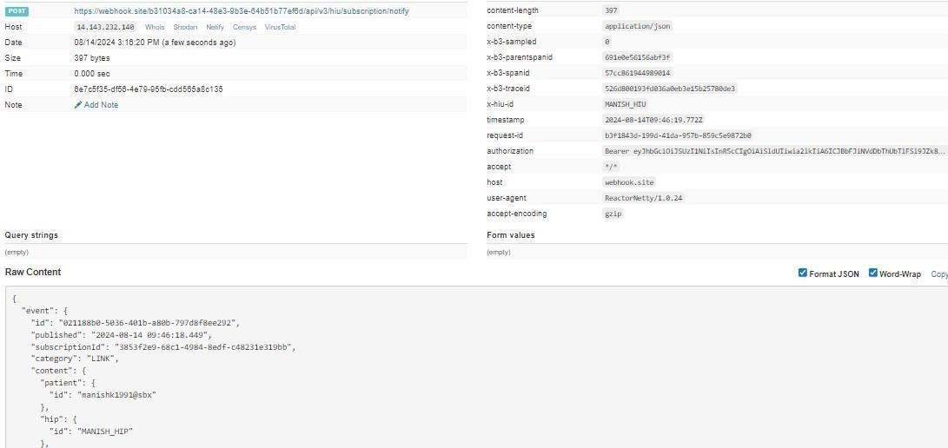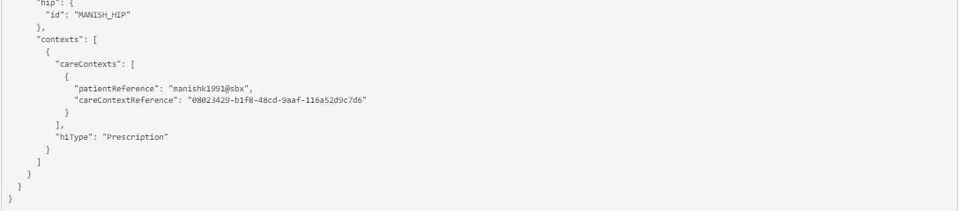

Subscription HIU –On-notify
This is the API that will be invoked to HIU to notify HIECM about the link new record notification received.
URL: /api/hiecm/subscription-requests/v3/hiu/care-context/on-notify Method: Post Request Headers:
Property  Name | Example Value | Required | Description
REQUEST-ID | 18235d89-cb13-  479d-ad717a57d5f669a8 | Yes | Unique UUID for track the end-to-end request transaction
TIMESTAMP | 2022-10-  06T10:10:00.587Z | Yes | Actual time when request was initiated, ISO Date time format represents date and time
X-CM-ID | sbx | Yes | Suffix of the consent manager to which the request was intended
Authorization | Gatteway Session Token | Yes | JWT Access token which was issued by ABDM session API after successful validation of client id and secret

Body parameters
Property Name | Example Value | Required | Description
acknowledgement | {  "status": "OK",  "eventId": "2b8ddd74-  5e5e-475b-877821603e05a8b4"  } | Yes | This is the acknowledgement from the HIU
Response | {  "requestId": "a4b51f47f70f-  4291-9599- 8e39b7893cfc"  } | Yes | This is the response ID is used from the initiate request ID

Request Body
Request Body:
{
"acknowledgement": {
"status": "OK",
"eventId": "2b8ddd74-5e5e-475b-8778-21603e05a8b4"
},
"response": {
"requestId": "a4b51f47-f70f-4291-9599-8e39b7893cfc"
}
}
Response
Response:
Code: 202 Accepted

API listing
No. | Flow | Serial |  | v3 API | Description
 | Subscripti on | 4.1 | /api/hiecm/subscriptionrequests/v3/requests?statu s=ALL&limit=10&offset=0 |  | API will be invoked by the patient/user from the PHR application to fetch his/her subscribed HIU details
 |  | 4.2 | /api/hiecm/subscriptionrequests/v3/init |  | API which will be invoked by the HIU to initiate subscription request to the patient/user from PHR application
 |  | 4.3 | {{call  back}}/api/v3/hiu/hiecm/s ubscriptionrequests/oninit |  | API which will be invoked by the HIU to initiate subscription request to the patient/user from PHR application.  In these two calls back will be received one by the HIU that request has been raised with the subscription request id and other will be received by the patient if patient is registered in the PHR app/health locker

 |  | 4.4 | /api/hiecm/subscriptionrequests/v3/hiu/on-notify | API that will be invoked by the HIU to notify HIECM that HIU has raised the subscription request
 |  | 4.5 | /api/hiecm/subscriptionrequests/v3/{subscription_r equestid}/approve | Api will be invoked by the patient/user from PHR application to approve the subscription request raised by the HIU
 |  | 4.6 | {{callback}}  /api/v3/hiu/subscriptionrequests/hiu/notify | HIECM will notify to the HIU about subscription request raised by the HIU is approved
 |  | 4.7 | /api/hiecm/subscriptionrequests/v3/hiu/carecontext/onnotify | api will be invoke by the HIU to notify HIECM about the subscription request has been approved or denied
 |  | 4.8 | /api/hiecm/subscriptionrequests/v3/{subscription_i d}}/deny | api will be invoke by the HIU to notify HIECM about the subscription request has been approved or denied
 |  | 4.9 | {{ call  back}}/api/v3/hiu/subscript ion-requests/hiu/notify | api will be invoke by the patient to deny the subscription request raise by the HIU
 |  | 4..10 | /api/hiecm/subscriptionrequests/v3/patients/{subs cription_id} | API will be invoked by the patient/user from PHR application to edit the subscription.
 | Consent Flow | 4.11 | /api/hiecm/consent/v3/req uest/init | API used to raise consent request
 |  | 4.12 | {callback}/api/v3/hiu/cons ent/request/on-init | Callback API used to notify hiu

 |  | 4.13 | /api/hiecm/consent/v3/req uest/status | API used to fetch the status of consent request
 |  | 4.14 | {callback_url}/api/v3/hiu/c onsent/request/on-status | Callback api is used to give the response of  status
 |  | 4.15 | /api/hiecm/consent/v3/fetc h | API used to fetch the consent details
 |  | 4.16 | {callback_url}  /api/v3/hiu/consent/onfetch | Callback api used to give a response of fetch api
 | Data flow | 4.17 | /api/hiecm/dataflow/v3/healthinformation/request | This api indicates the exchange of health data request from HIU to HIP
 |  | 4.18 | {callback_url/api/v3/hiu/he alth-information/onrequest | callback API for acknowledgment of Health information request of HIU. CM calls this API when it has validated the Health Information request given the consent id. •  Either the  hiRequest or error would need to be specified. If the health info request was valid, then the hiRequest.transactionId specifies the transaction context against which HIP would send over the data
API will be called by HIU and HIP to notify the CM about the status of the data transfer.

HIP on the transfer of data would send sessionStatus - one of [TRANSFERRED, FAILED]. HIP would also send hiStatus for each careContextReference - on of
[DELIVERED, ERRORED]
•
HIU on receipt of data would send sessionStatus - one of [RECEIVED, FAILED]. For example, ERRORED when data was not sent or if invalid data was sent. HIU would also send hiStatus for each careContextReference - one of [OK, ERRORED].
 |  | 4.19 | /api/hiecm/dataflow/v3/healthinformation/notify

7 Error codes listing
Code | Error
ABDM-1000 | Unable to connect the database
ABDM-1001 | No data found
ABDM-1002 | Integrity violation
ABDM-1003 | Email Gateway is unavailable
ABDM-1004 | SMS Gateway is unavailable

ABDM-1005 | Invalid receiver
ABDM-1006 | Bad Request, invalid request Body
ABDM-1007 | Connection failed due to timeout
ABDM-1008 | SMS service currently disabled
ABDM-1009 | Email service currently disabled
ABDM-1010 | Validation failed
ABDM-1011 | Gateway database unavailable
ABDM-1012 | No records found against the ABHA Address
ABDM-1013 | Invalid ABHA Number
ABDM-1014 | Invalid Mobile Email
ABDM-1015 | Invalid Response
ABDM-1016 | Invalid TimeStamp
ABDM-1017 | Invalid TransactionId
ABDM-1018 | Share Profile database unavailable
ABDM-1019 | Dependent Service Unavailable
ABDM-1020 | Unknown database
ABDM-1021 | Lack of required priviledges
ABDM-1022 | Too many requests
ABDM-1023 | Invalid User
ABDM-1024 | Dependent service unavailable
ABDM-1025 | Invalid ServiceId
ABDM-1026 | Invalid Link Token
ABDM-1027 | You are blocked. Please try again after 24 hours.
ABDM-1028 | HIP is unavailable
ABDM-1029 | Redis server is unavailable
ABDM-1030 | Invalid request ID
ABDM-1031 | Invalid request
ABDM-1032 | Invalid header
ABDM-1033 | HIU is unavailable
ABDM-1034 | Notification service unavailable
ABDM-1035 | Invalid HIP ID

ABDM-1035 | OTP does not matched
ABDM-1036 | Data does not matched
ABDM-1037 | Counter and Care context count mismatch
ABDM-1038 | ABHA address and Link token mismatch
ABDM-1039 | Invalid Consent request id
ABDM-1040 | Invalid HIU ID
ABDM-1041 | Invalid Acknowledgement
ABDM-1042 | Provider Mandatory
ABDM-1043 | ABHA Address does not match with KYC details.
ABDM-1044 | Broadcast Failed
ABDM-1045 | Database Access is restricted
ABDM-1046 | Invalid Purpose
ABDM-1047 | Purpose does not exist
ABDM-1048 | Timeout
ABDM-1049 | Invalid Profile Share Intent Keys
ABDM-1050 | Invalid Profile Share Metadata Keys
ABDM-1051 | Invalid ABHA Number or ABHA Address
ABDM-1052 | Invalid TransactionId or response's requestId
ABDM-1053 | Data already exists
ABDM-1054 | Invalid Subscription Request Id
ABDM-1401 | HIP is not available
ABDM-1402 | Acknowledgement is not received from HIP
ABDM-9999 | Unknown exception
ABDM-1061 | Consent artefact expired
ABDM-1062 | Consent Not granted
ABDM-1063 | Date Range given is invalid
ABDM-1064 | request with this request id already exists
ABDM-1017 | Invalid TransactionId
ABDM-1109 | ABHA DB service unavailable
ABDM-1108 | Notification DB service unavailable
ABDM-1205 | Document DB Gateway is unavailable
ABDM-1034 | Notification service unavailable
ABDM-1029 | Redis server is unavailable
ABDM-1202 | Document Gateway is unavailable
ABDM-1200 | LGD Gateway is unavailable
ABDM-1201 | IDP Gateway is unavailable
ABDM-9999 | Unknown exception
ABDM-1101 | This ABHA Address already exists. Please create with unique ABHA Address
ABDM-1006 | Invalid combinations of scopes
ABDM-1100 | You have requested multiple OTPs Or Exceeded maximum number of attempts for OTP match in this transaction.  Please try again in 30 minutes.
ABDM-1006 | Bad Request, invalid request Body
ABDM-1110 | ABHA User not found.
ABDM-1111 | Mobile number not found.
ABDM-1112 | Aadhaar details not found.
ABDM-1113 | Login via Password is not allowed
ABDM-1114 | Login via ABHA Number OTP is not allowed
ABDM-1115 | Login via Aadhaar OTP is not allowed
ABDM-1102 | Mobile number verification is pending.
ABDM-1203 | {errors coming from DL gateway(Nepix)}
ABDM-1204 | {errors coming from Aadhaar gateway(UIDAI)}

